**MY TANJORE**

**Project Report**

Submitted in partial fulfillment for the award of Course of

**Rich Internet Mobility Application (Android)**

Of

**Atom Training Labs**

*By*

**R.VISHNUPRASAD**

**Enroll .No. ATSTM605**

Under the guidance of

**Mr .P.vijayakrishnan**

**(Technical Delivery Head)**



**Atom Training Labs**

**No 2 Aravind Plazas, Fort Station Road,**

**Chathiram Bus Stand,**

**Trichy - 620002,**

**ABSTRACT:**

My Tanjore application developed on android studio. This application helps to know information’s about tourist place in thanjavur and how to reach that place by road, rail and air.

Room booking tab have details of hotels and book available rooms on that hotels. Shopping in Thanjavur tab help to kown details about traditional products in thanjavur and to bought it.

This app has details about thanjavur tourism. It has pictures of Tourist place and has history of that places. It has details about magamagam festival and its images.

**MODULES:**

On this first page of this app has welcome button, press this button open second activity that has following buttons as

* + TOURIST PLACE
  + ROOM BOOKING
  + HOW TO REACH
  + SHOPPING IN THANJAVUR
  + ABOUT THANJAVUR
  + EXIT

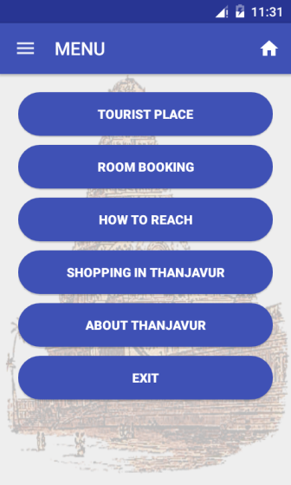

1. **TOURIST PLACE**

Tourist place contains following buttons as

* BRIHADEESHWARA TEMPLE
* ROYAL PALACE AND ART GALLERY
* KALLANAI DAM
* KUMBAKONAM
* SWAMI MALAI
* POONDI MADHA BASILICA

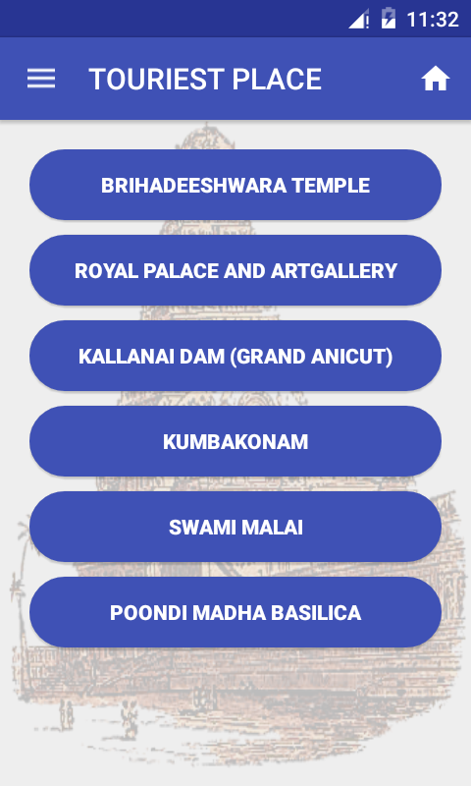

1. **BRIHADEESHWARA TEMPLE**

On this tab contains details and images of thanjavur big temple. It is most important place in thanjavur.

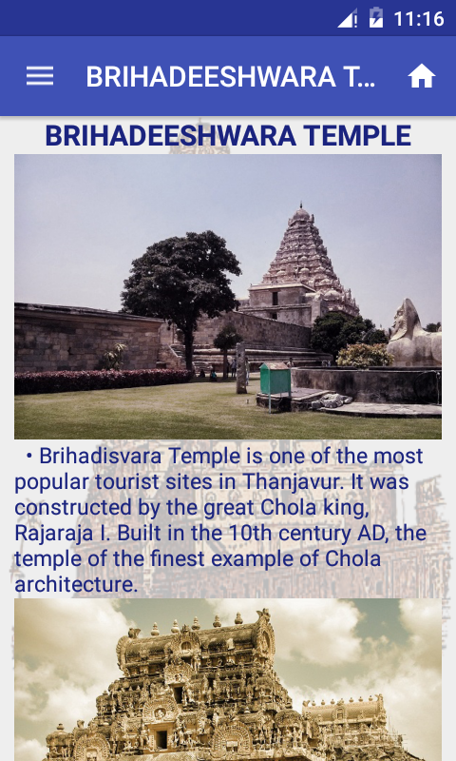

1. **ROYAL PALACE AND ART GALLERY**

On this tab contains details and images of Royal Palace and artgallery.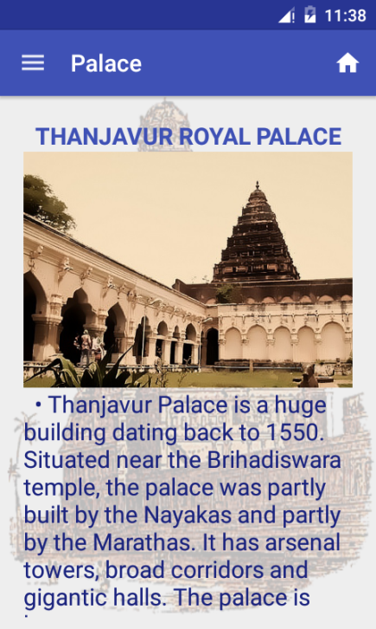

1. **KALLANAI DAM**

On this tab contains details and images of kallan dam.

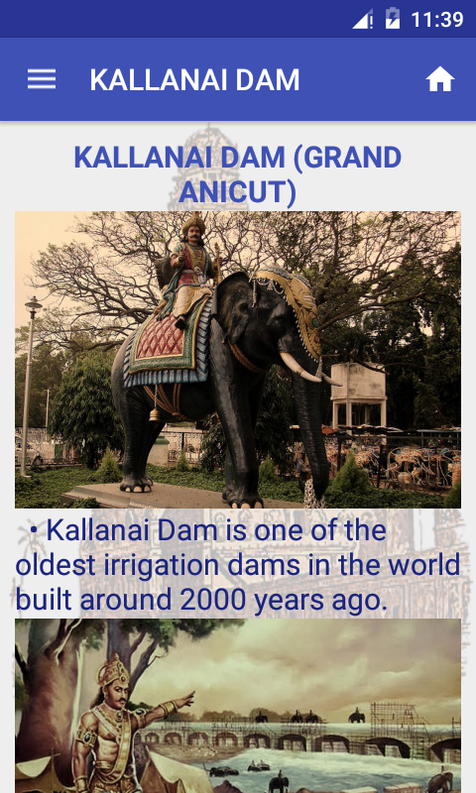

1. **KUMBAKONAM**

On this tab contains details and images of kumbakonam town. It is famous temple town in thanjavur.

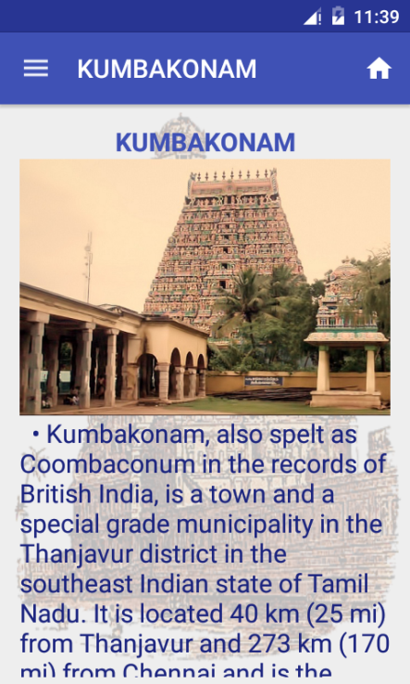

1. **SWAMI MALAI**

On this tab contains details and images of swamimalai. Swamimalai is a god Murugan temple.

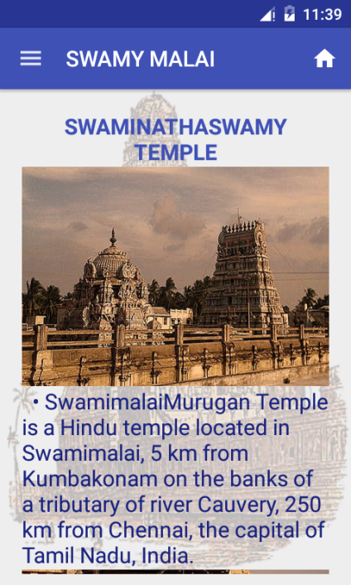

1. **POONDI MADHA BASILICA**

On this tab contains details and images of poondi madha basilica. It is famous Christian church in tamilnadu.

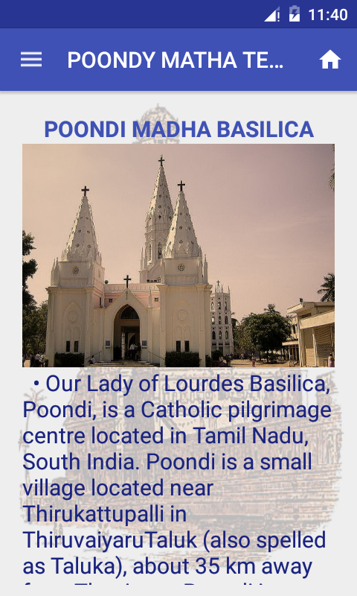

1. **ROOM BOOKING**

Room booking is tab view concept it has two tabs as hotel details and Room booking. Hotel details tab contains details of normal, two star and three star hotels in thanjavur city. And room booking tabs contains details of available rooms in those hotels.

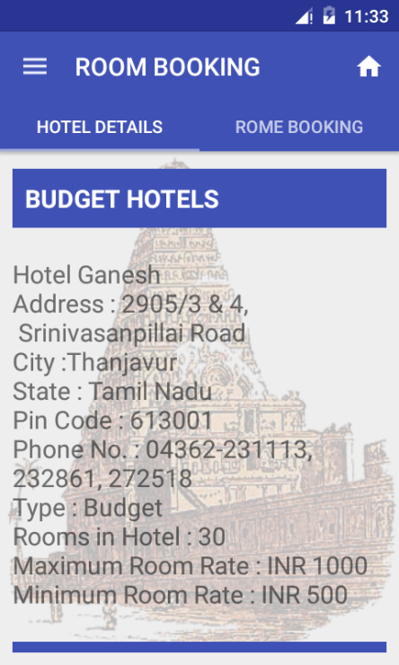

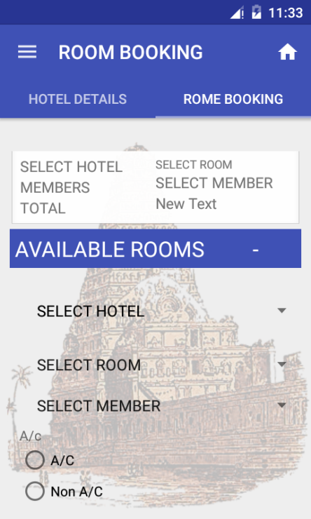

1. **HOW TO REACH**

How to reach activity describe how to reach thanjavur city by road, rail and air.

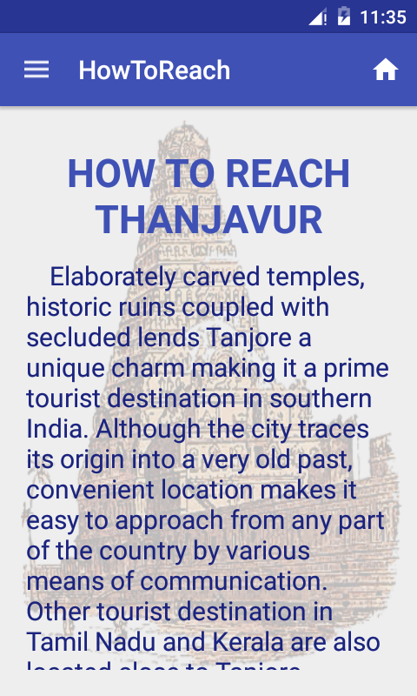

1. **SHOPPING IN THANJAVUR**

Shopping in Thanjavur activity help to kown details about traditional products in thanjavur and to bought it.

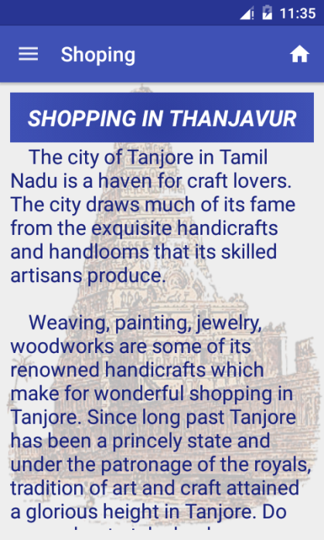

1. **ABOUT THANJAVUR**

Finally about thanjavur activity contains information about the thanjavur tourism.

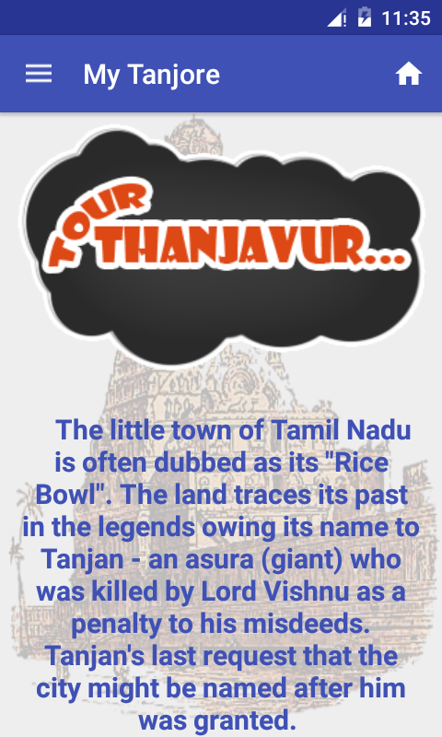

1. **EXIT**

Exit button help exit from application.

**NAVIGATION LAYOUT**

Navigation layout contains following items as Tourist place, Room booking, How to reach, Shopping in thanjavur and about thanjavur . If tab any items open that activity.

**JAVA AND XML SOURCE CODE**

**BRIHADEESHWARA TEMPLE.**

**XML CODE**

*<?*xml version="1.0" encoding="utf-8"*?>*<android.support.v4.widget.DrawerLayout  
 xmlns:android="http://schemas.android.com/apk/res/android"  
 xmlns:app="http://schemas.android.com/apk/res-auto"  
 android:id="@+id/drawer_layout"  
 android:layout_width="match_parent"  
 android:layout_height="match_parent">  
  
 <android.support.design.widget.CoordinatorLayout xmlns:android="http://schemas.android.com/apk/res/android"  
 xmlns:app="http://schemas.android.com/apk/res-auto"  
 xmlns:tools="http://schemas.android.com/tools"  
 android:layout_width="match_parent"  
 android:layout_height="match_parent"  
 android:fitsSystemWindows="true"  
 tools:context="com.example.vishnu.fpro.Braka">  
  
 <android.support.design.widget.AppBarLayout  
 android:layout_width="match_parent"  
 android:layout_height="wrap_content"  
 android:theme="@style/AppTheme.AppBarOverlay">  
  
 <android.support.v7.widget.Toolbar  
 android:id="@+id/toolbar"  
 android:layout_width="match_parent"  
 android:layout_height="?attr/actionBarSize"  
 android:background="?attr/colorPrimary"  
 app:popupTheme="@style/AppTheme.PopupOverlay" />  
  
 </android.support.design.widget.AppBarLayout>  
  
 <include layout="@layout/content_braka" />  
  
  
 </android.support.design.widget.CoordinatorLayout>  
  
 <android.support.design.widget.NavigationView  
 android:id="@+id/nvView"  
 android:layout_width="wrap_content"  
 android:layout_height="match_parent"  
 android:layout_gravity="start"  
 android:src="@android:drawable/ic_dialog_email"  
 app:menu="@menu/drawer_view" />  
</android.support.v4.widget.DrawerLayout>

*<?*xml version="1.0" encoding="utf-8"*?>*<ScrollView xmlns:android="http://schemas.android.com/apk/res/android"  
 xmlns:app="http://schemas.android.com/apk/res-auto"  
 xmlns:tools="http://schemas.android.com/tools"  
 android:background="@mipmap/bimages"  
 android:layout_width="match_parent"  
 android:layout_height="fill_parent"  
 app:layout_behavior="@string/appbar_scrolling_view_behavior"  
 tools:context="com.example.vishnu.fpro.Braka"  
 tools:showIn="@layout/activity_braka">  
  
 <LinearLayout  
 android:orientation="vertical"  
 android:layout_width="match_parent"  
 android:layout_height="fill_parent"  
 android:layout_margin="10dp">  
  
 <TextView  
 android:layout_width="match_parent"  
 android:layout_height="wrap_content"  
 android:gravity="center"  
 android:textStyle="bold"  
 android:textSize="20dp"  
 android:textColor="@color/TextColor"  
 android:text="BRIHADEESHWARA TEMPLE"  
 android:id="@+id/textView" />  
  
 <ImageButton  
 android:layout_width="fill_parent"  
 android:layout_height="200dp"  
 android:id="@+id/imageButton"  
 android:background="@drawable/bhra1"/>  
  
 <TextView  
 android:layout_width="wrap_content"  
 android:layout_height="wrap_content"  
 android:textColor="@color/TextColor"  
 android:textSize="15dp"  
 android:text=" • Brihadisvara Temple is one of the most popular tourist sites in Thanjavur. It was constructed by the great Chola king, Rajaraja I. Built in the 10th century AD, the temple of the finest example of Chola architecture."  
 android:id="@+id/textView3" />  
  
 <ImageView  
 android:layout_width="fill_parent"  
 android:layout_height="200dp"  
 android:id="@+id/imageView2"  
 android:background="@drawable/bhra2"/>  
  
 <TextView  
 android:layout_width="wrap_content"  
 android:layout_height="wrap_content"  
 android:textColor="@color/TextColor"  
 android:textSize="15dp"  
 android:text=" • The architecture of the Brihadisvara Temple of Thanjavur is reminiscent of the Egyptian pyramids. The temple is about 63 meters high. The dome of the temple is said to be built with the help of a gigantic piece of granite. The granite which is used to build the dome of the temple is estimated to weigh about 81 tonnes. The dome of the temple is a grandeur in architecture."  
 android:id="@+id/textView4" />  
  
 <ImageView  
 android:layout_width="fill_parent"  
 android:layout_height="200dp"  
  
 android:id="@+id/imageView3"  
 android:background="@drawable/bhra3"/>  
 <TextView  
 android:layout_width="wrap_content"  
 android:layout_height="wrap_content"  
 android:textColor="@color/TextColor"  
 android:textSize="15dp"  
 android:layout_marginBottom="40dp"  
 android:text=" • Brihadisvara Temple is one of the important shrines in the city. Every year thousands of tourists come to Thanjavur to reverence to the titular deity. Moreover, it is noteworthy that Brihadisvara Temple in Thanjavur has certain restrictions about entering the shrine. According to the rules and regulation of the temple, only Hindus are permitted to go inside the temple and worship there. Others are exempted from entering the temple"  
 android:id="@+id/textView5" />  
 </LinearLayout>  
</ScrollView>

**JAVA CODE**

Package com.example.vishnu.fpro;

import android.content.Intent;

import android.os.Bundle;

import android.support.design.widget.FloatingActionButton;

import android.support.design.widget.NavigationView;

import android.support.design.widget.Snackbar;

import android.support.v4.view.GravityCompat;

import android.support.v4.widget.DrawerLayout;

import android.support.v7.app.ActionBarDrawerToggle;

import android.support.v7.app.AppCompatActivity;

import android.support.v7.widget.Toolbar;

import android.view.Menu;

import android.view.MenuItem;

import android.view.View;

public class Braka extends AppCompatActivity implements NavigationView.OnNavigationItemSelectedListener {

@Override

protected void onCreate(Bundle savedInstanceState) {

super.onCreate(savedInstanceState);

setContentView(R.layout.activity_braka);

Toolbar toolbar = (Toolbar) findViewById(R.id.toolbar);

setSupportActionBar(toolbar);

DrawerLayout mDrawer = (DrawerLayout) findViewById(R.id.drawer_layout);

ActionBarDrawerToggle toggle = new ActionBarDrawerToggle(

this, mDrawer, toolbar, R.string.navigation_drawer_open, R.string.navigation_drawer_close);

mDrawer.setDrawerListener(toggle);

toggle.syncState();

NavigationView nvDrawer = (NavigationView) findViewById(R.id.nvView);

View headerLayout = nvDrawer.inflateHeaderView(R.layout.nav_header);

nvDrawer.setNavigationItemSelectedListener(this);

}

public void onBackPressed() {

DrawerLayout drawer = (DrawerLayout) findViewById(R.id.drawer_layout);

if (drawer.isDrawerOpen(GravityCompat.START)) {

drawer.closeDrawer(GravityCompat.START);

} else {

super.onBackPressed();

}

}

@Override

public boolean onCreateOptionsMenu(Menu menu) {

getMenuInflater().inflate(R.menu.menu_main,menu);

return true;

}

public boolean onOptionsItemSelected(MenuItem item) {

// Handle action bar item clicks here. The action bar will

// automatically handle clicks on the Home/Up button, so long

// as you specify a parent activity in AndroidManifest.xml.

int id = item.getItemId();

//noinspection SimplifiableIfStatement

if (id == R.id.action_settings) {

Intent intent = new Intent(getApplicationContext(),Home.class);

startActivity(intent);

return true;

}

return super.onOptionsItemSelected(item);

}

@Override

public boolean onNavigationItemSelected(MenuItem item) {

int id = item.getItemId();

if (id == R.id.nav_first_fragment) {

Intent intent = new Intent(Braka.this, ListHome.class);

startActivity(intent);

} else if (id == R.id.nev_second_fragment) {

Intent intent = new Intent(Braka.this, Main2Activity.class);

startActivity(intent);

} else if (id == R.id.nev_third) {

Intent intent = new Intent(Braka.this, HowToReach.class);

startActivity(intent);

} else if (id == R.id.nev_four) {

Intent intent = new Intent(Braka.this, Shoping.class);

startActivity(intent);

} else if (id == R.id.nev_five) {

Intent intent = new Intent(Braka.this, MainActivity.class);

startActivity(intent);

}

DrawerLayout drawer = (DrawerLayout) findViewById(R.id.drawer_layout);

drawer.closeDrawer(GravityCompat.START);

return true;

}

}

**WELCOME**

**XML CODE**

<?xml version="1.0" encoding="utf-8"?>

<RelativeLayout xmlns:android="http://schemas.android.com/apk/res/android"

xmlns:app="http://schemas.android.com/apk/res-auto"

xmlns:tools="http://schemas.android.com/tools"

android:layout_width="fill_parent"

android:layout_height="fill_parent"

android:gravity="center"

android:background="@mipmap/bimages"

app:layout_behavior="@string/appbar_scrolling_view_behavior"

tools:context="com.example.vishnu.fpro.Home"

tools:showIn="@layout/activity_home">

<LinearLayout

android:orientation="vertical"

android:layout_width="match_parent"

android:layout_height="match_parent"

android:layout_alignParentTop="true"

android:layout_centerHorizontal="true"

android:layout_marginTop="10dp"

android:gravity="center">

<Button

android:layout_width="200dp"

android:layout_height="200dp"

android:text="WELCOME"

android:textStyle="bold"

android:textSize="30dp"

android:textColor="#fff"

android:onClick="welcome"

android:background="@drawable/roundbt"

android:id="@+id/welcome"

android:layout_gravity="center_horizontal" />

</LinearLayout>

</RelativeLayout>

**JAVA CODE**

package com.example.vishnu.fpro;

import android.content.Intent;

import android.os.Bundle;

import android.support.design.widget.FloatingActionButton;

import android.support.design.widget.NavigationView;

import android.support.design.widget.Snackbar;

import android.support.v4.view.GravityCompat;

import android.support.v4.widget.DrawerLayout;

import android.support.v7.app.ActionBarDrawerToggle;

import android.support.v7.app.AppCompatActivity;

import android.support.v7.widget.Toolbar;

import android.view.Menu;

import android.view.MenuItem;

import android.view.View;

import android.widget.Button;

public class Home extends AppCompatActivity implements NavigationView.OnNavigationItemSelectedListener {

Button b;

DrawerLayout mDrawer;

NavigationView nvDrawer;

@Override

protected void onCreate(Bundle savedInstanceState) {

super.onCreate(savedInstanceState);

setContentView(R.layout.activity_home);

Toolbar toolbar = (Toolbar) findViewById(R.id.toolbar);

setSupportActionBar(toolbar);

b = (Button) findViewById(R.id.welcome);

mDrawer = (DrawerLayout) findViewById(R.id.drawer_layout);

ActionBarDrawerToggle toggle = new ActionBarDrawerToggle(

this, mDrawer, toolbar, R.string.navigation_drawer_open, R.string.navigation_drawer_close);

mDrawer.setDrawerListener(toggle);

toggle.syncState();

nvDrawer = (NavigationView) findViewById(R.id.nvView);

View headerLayout = nvDrawer.inflateHeaderView(R.layout.nav_header);

nvDrawer.setNavigationItemSelectedListener(this);

}

public void onBackPressed() {

DrawerLayout drawer = (DrawerLayout) findViewById(R.id.drawer_layout);

if (drawer.isDrawerOpen(GravityCompat.START)) {

drawer.closeDrawer(GravityCompat.START);

} else {

super.onBackPressed();

}

}

public void welcome(View view) {

Intent tou = new Intent(Home.this, ListHome.class);

startActivity(tou);

}

@Override

public boolean onCreateOptionsMenu(Menu menu) {

// Inflate the menu; this adds items to the action bar if it is present.

getMenuInflater().inflate(R.menu.menu_main, menu);

return true;

}

public boolean onOptionsItemSelected(MenuItem item) {

// Handle action bar item clicks here. The action bar will

// automatically handle clicks on the Home/Up button, so long

// as you specify a parent activity in AndroidManifest.xml.

int id = item.getItemId();

//noinspection SimplifiableIfStatement

if (id == R.id.action_settings) {

Intent intent = new Intent(getApplicationContext(),Home.class);

startActivity(intent);

return true;

}

return super.onOptionsItemSelected(item);

}

@Override

public boolean onNavigationItemSelected(MenuItem item) {

int id = item.getItemId();

if (id == R.id.nav_first_fragment) {

Intent intent = new Intent(Home.this, ListHome.class);

startActivity(intent);

} else if (id == R.id.nev_second_fragment) {

Intent intent = new Intent(Home.this, Main2Activity.class);

startActivity(intent);

} else if (id == R.id.nev_third) {

Intent intent = new Intent(Home.this, HowToReach.class);

startActivity(intent);

} else if (id == R.id.nev_four) {

Intent intent = new Intent(Home.this, Shoping.class);

startActivity(intent);

} else if (id == R.id.nev_five) {

Intent intent = new Intent(Home.this, MainActivity.class);

startActivity(intent);

}

DrawerLayout drawer = (DrawerLayout) findViewById(R.id.drawer_layout);

drawer.closeDrawer(GravityCompat.START);

return true;

}

}

**HOW TO REACH**

**XML CODE**

*<?*xml version="1.0" encoding="utf-8"*?>*<ScrollView xmlns:android="http://schemas.android.com/apk/res/android"  
 xmlns:app="http://schemas.android.com/apk/res-auto"  
 xmlns:tools="http://schemas.android.com/tools"  
 android:layout_width="match_parent"  
 android:layout_height="match_parent"  
 android:background="@mipmap/bimages"  
 android:layout_margin="10dp"  
 android:padding="10dp"  
 app:layout_behavior="@string/appbar_scrolling_view_behavior"  
 tools:context="com.example.vishnu.fpro.HowToReach"  
 tools:showIn="@layout/activity_how_to_reach">  
  
 <LinearLayout  
 android:layout_width="match_parent"  
 android:layout_height="wrap_content"  
 android:layout_marginBottom="20dp"  
 android:layout_marginTop="10dp"  
 android:orientation="vertical"  
 android:paddingBottom="20dp">  
  
 <TextView  
 android:id="@+id/travel"  
 android:layout_width="fill_parent"  
 android:layout_height="wrap_content"  
 android:layout_margin="10dp"  
 android:gravity="center"  
 android:text="HOW TO REACH THANJAVUR"  
 android:textColor="@color/btncolor"  
 android:textSize="30dp"  
 android:textStyle="bold" />  
  
 <TextView  
 android:id="@+id/textView8"  
 android:layout_width="wrap_content"  
 android:layout_height="wrap_content"  
 android:text=" \t Elaborately carved temples, historic ruins coupled with secluded lends Tanjore a unique charm making it a prime tourist destination in southern India. Although the city traces its origin into a very old past, convenient location makes it easy to approach from any part of the country by various means of communication. Other tourist destination in Tamil Nadu and Kerala are also located close to Tanjore. Convenient network of air, road and rail connects Tanjore to other cities of the region."  
 android:textColor="@color/TextColor"  
 android:textSize="20dp" />  
  
 <TextView  
 android:id="@+id/air"  
 android:layout_width="wrap_content"  
  
 android:layout_height="wrap_content"  
 android:layout_gravity="left"  
 android:layout_margin="10dp"  
 android:text="BY AIR"  
 android:textColor="@color/btncolor"  
 android:textSize="25dp"  
 android:textStyle="bold" />  
  
 <TextView  
 android:id="@+id/airds"  
 android:layout_width="wrap_content"  
 android:layout_height="wrap_content"  
 android:layout_gravity="left"  
 android:layout_margin="10dp"  
 android:text=" \t The city does not have an airport of its own. The nearest airport is in Trichy only 54kms away from Tanjore. Many private and public airlines operate domestic flights to and from Trichy. Some other international airlines too operate regular flights to this airport."  
 android:textColor="@color/TextColor"  
 android:textSize="20dp" />  
  
 <TextView  
 android:id="@+id/road"  
 android:layout_width="wrap_content"  
  
 android:layout_height="wrap_content"  
 android:layout_gravity="left"  
 android:layout_margin="10dp"  
 android:text="BY ROAD"  
 android:textColor="@color/btncolor"  
 android:textSize="25dp"  
 android:textStyle="bold" />  
  
 <TextView  
 android:id="@+id/roadds"  
 android:layout_width="wrap_content"  
 android:layout_height="wrap_content"  
 android:layout_gravity="left"  
 android:layout_margin="10dp"  
 android:text=" \t A good network of well maintained roads connect Tanjore with major south Indian cities like Chennai, Madurai, Trichy and so on. These places again are linked to rest of the country by road."  
 android:textColor="@color/TextColor"  
 android:textSize="20dp" />  
  
 <TextView  
 android:id="@+id/train"  
 android:layout_width="wrap_content"  
  
 android:layout_height="wrap_content"  
 android:layout_gravity="left"  
 android:layout_margin="10dp"  
 android:text="BY TRAIN"  
 android:textColor="@color/btncolor"  
 android:textSize="25dp"  
 android:textStyle="bold" />  
  
 <TextView  
 android:id="@+id/trainds"  
 android:layout_width="wrap_content"  
 android:layout_height="wrap_content"  
 android:layout_gravity="left"  
 android:layout_margin="10dp"  
 android:layout_marginBottom="20dp"  
 android:text=" \t The city has a railway station of its own. A well laid out rail network links Tanjore with cities in this part of India. Many important trains service the station regularly."  
 android:textColor="@color/TextColor"  
 android:textSize="20dp" />  
  
 </LinearLayout>  
  
</ScrollView>

**JAVA CODE**

package com.example.vishnu.fpro;

import android.content.Intent;

import android.os.Bundle;

import android.support.design.widget.FloatingActionButton;

import android.support.design.widget.NavigationView;

import android.support.design.widget.Snackbar;

import android.support.v4.view.GravityCompat;

import android.support.v4.widget.DrawerLayout;

import android.support.v7.app.ActionBarDrawerToggle;

import android.support.v7.app.AppCompatActivity;

import android.support.v7.widget.Toolbar;

import android.view.Menu;

import android.view.MenuItem;

import android.view.View;

import android.widget.TextView;

public class HowToReach extends AppCompatActivity implements NavigationView.OnNavigationItemSelectedListener {

TextView t;

@Override

protected void onCreate(Bundle savedInstanceState) {

super.onCreate(savedInstanceState);

setContentView(R.layout.activity_how_to_reach);

Toolbar toolbar = (Toolbar) findViewById(R.id.toolbar);

setSupportActionBar(toolbar);

t=(TextView)findViewById(R.id.travel);

/*t.setText("");*/

DrawerLayout mDrawer = (DrawerLayout) findViewById(R.id.drawer_layout);

ActionBarDrawerToggle toggle = new ActionBarDrawerToggle(

this, mDrawer, toolbar, R.string.navigation_drawer_open, R.string.navigation_drawer_close);

mDrawer.setDrawerListener(toggle);

toggle.syncState();

NavigationView nvDrawer = (NavigationView) findViewById(R.id.nvView);

View headerLayout = nvDrawer.inflateHeaderView(R.layout.nav_header);

nvDrawer.setNavigationItemSelectedListener(this);

}

public void onBackPressed() {

DrawerLayout drawer = (DrawerLayout) findViewById(R.id.drawer_layout);

if (drawer.isDrawerOpen(GravityCompat.START)) {

drawer.closeDrawer(GravityCompat.START);

} else {

super.onBackPressed();

}

}

public boolean onCreateOptionsMenu(Menu menu) {

// Inflate the menu; this adds items to the action bar if it is present.

getMenuInflater().inflate(R.menu.menu_main, menu);

return true;

}

public boolean onOptionsItemSelected(MenuItem item) {

// Handle action bar item clicks here. The action bar will

// automatically handle clicks on the Home/Up button, so long

// as you specify a parent activity in AndroidManifest.xml.

int id = item.getItemId();

//noinspection SimplifiableIfStatement

if (id == R.id.action_settings) {

Intent intent = new Intent(getApplicationContext(),Home.class);

startActivity(intent);

return true;

}

return super.onOptionsItemSelected(item);

}

@Override

public boolean onNavigationItemSelected(MenuItem item) {

int id = item.getItemId();

if (id == R.id.nav_first_fragment) {

Intent intent = new Intent(HowToReach.this, ListHome.class);

startActivity(intent);

} else if (id == R.id.nev_second_fragment) {

Intent intent = new Intent(HowToReach.this, Main2Activity.class);

startActivity(intent);

} else if (id == R.id.nev_third) {

Intent intent = new Intent(HowToReach.this, HowToReach.class);

startActivity(intent);

} else if (id == R.id.nev_four) {

Intent intent = new Intent(HowToReach.this, Shoping.class);

startActivity(intent);

} else if (id == R.id.nev_five) {

Intent intent = new Intent(HowToReach.this, MainActivity.class);

startActivity(intent);

}

DrawerLayout drawer = (DrawerLayout) findViewById(R.id.drawer_layout);

drawer.closeDrawer(GravityCompat.START);

return true;

}}

**KALLANAI DAM**

**XML CODE**

<?xml version="1.0" encoding="utf-8"?>

<ScrollView xmlns:android="http://schemas.android.com/apk/res/android"

xmlns:app="http://schemas.android.com/apk/res-auto"

xmlns:tools="http://schemas.android.com/tools"

android:layout_width="match_parent"

android:layout_height="match_parent"

android:background="@mipmap/bimages"

app:layout_behavior="@string/appbar_scrolling_view_behavior"

tools:context="com.example.vishnu.fpro.kallanai"

tools:showIn="@layout/activity_kallanai">

<LinearLayout

android:orientation="vertical"

android:layout_width="match_parent"

android:layout_height="fill_parent"

android:layout_margin="10dp">

<TextView

android:layout_width="match_parent"

android:layout_height="wrap_content"

android:gravity="center"

android:textStyle="bold"

android:textSize="20dp"

android:textColor="@color/btncolor"

android:text="KALLANAI DAM (GRAND ANICUT)"

android:id="@+id/textView" />

<ImageButton

android:layout_width="fill_parent"

android:layout_height="200dp"

android:id="@+id/imageButton"

android:background="@drawable/kallanai1"/>

<TextView

android:layout_width="wrap_content"

android:layout_height="wrap_content"

android:textColor="@color/TextColor"

android:textSize="20dp"

android:text=" • Kallanai Dam is one of the oldest irrigation dams in the world built around 2000 years ago. "

android:id="@+id/textView3" />

<ImageView

android:layout_width="fill_parent"

android:layout_height="200dp"

android:id="@+id/imageView2"

android:background="@drawable/kallanai2"/>

<TextView

android:layout_width="wrap_content"

android:layout_height="wrap_content"

android:textColor="@color/TextColor"

android:textSize="20dp"

android:text=" • It was built across the river Cauvery by the Chola King, KarikalValavan. The main purpose of building Kallanai was to divert the Cauvery water for irrigation in the Tanjavur delta."

android:id="@+id/textView4" />

<ImageView

android:layout_width="fill_parent"

android:layout_height="200dp"

android:id="@+id/imageView3"

android:background="@drawable/kallanai3"/>

<TextView

android:layout_width="wrap_content"

android:layout_height="wrap_content"

android:textColor="@color/TextColor"

android:textSize="20dp"

android:layout_marginBottom="40dp"

android:text=" • Kallanai has a strong foundation and solid structure. Due to its stubbornness it is still in excellent condition and is used as a major irrigation dam in Tamilnadu."

android:id="@+id/textView5" />

</LinearLayout

</ScrollView>

**JAVA CODE**

package com.example.vishnu.fpro;

import android.content.Intent;

import android.os.Bundle;

import android.support.design.widget.FloatingActionButton;

import android.support.design.widget.NavigationView;

import android.support.design.widget.Snackbar;

import android.support.v4.view.GravityCompat;

import android.support.v4.widget.DrawerLayout;

import android.support.v7.app.ActionBarDrawerToggle;

import android.support.v7.app.AppCompatActivity;

import android.support.v7.widget.Toolbar;

import android.view.Menu;

import android.view.MenuItem;

import android.view.View;

public class kallanai extends AppCompatActivity implements NavigationView.OnNavigationItemSelectedListener {

@Override

protected void onCreate(Bundle savedInstanceState) {

super.onCreate(savedInstanceState);

setContentView(R.layout.activity_kallanai);

Toolbar toolbar = (Toolbar) findViewById(R.id.toolbar);

setSupportActionBar(toolbar);

DrawerLayout mDrawer = (DrawerLayout) findViewById(R.id.drawer_layout);

ActionBarDrawerToggle toggle = new ActionBarDrawerToggle(

this, mDrawer, toolbar, R.string.navigation_drawer_open, R.string.navigation_drawer_close);

mDrawer.setDrawerListener(toggle);

toggle.syncState();

NavigationView nvDrawer = (NavigationView) findViewById(R.id.nvView);

View headerLayout = nvDrawer.inflateHeaderView(R.layout.nav_header);

nvDrawer.setNavigationItemSelectedListener(this);

}

public void onBackPressed() {

DrawerLayout drawer = (DrawerLayout) findViewById(R.id.drawer_layout);

if (drawer.isDrawerOpen(GravityCompat.START)) {

drawer.closeDrawer(GravityCompat.START);

} else {

super.onBackPressed();

}

}

public boolean onCreateOptionsMenu(Menu menu) {

// Inflate the menu; this adds items to the action bar if it is present.

getMenuInflater().inflate(R.menu.menu_main, menu);

return true;

}

public boolean onOptionsItemSelected(MenuItem item) {

// Handle action bar item clicks here. The action bar will

// automatically handle clicks on the Home/Up button, so long

// as you specify a parent activity in AndroidManifest.xml.

int id = item.getItemId();

//noinspection SimplifiableIfStatement

if (id == R.id.action_settings) {

Intent intent = new Intent(getApplicationContext(),Home.class);

startActivity(intent);

return true;

}

return super.onOptionsItemSelected(item);

}

@Override

public boolean onNavigationItemSelected(MenuItem item) {

int id = item.getItemId();

if (id == R.id.nav_first_fragment) {

Intent intent = new Intent(kallanai.this, ListHome.class);

startActivity(intent);

} else if (id == R.id.nev_second_fragment) {

Intent intent = new Intent(kallanai.this, Main2Activity.class);

startActivity(intent);

} else if (id == R.id.nev_third) {

Intent intent = new Intent(kallanai.this, HowToReach.class);

startActivity(intent);

} else if (id == R.id.nev_four) {

Intent intent = new Intent(kallanai.this, Shoping.class);

startActivity(intent);

} else if (id == R.id.nev_five) {

Intent intent = new Intent(kallanai.this, MainActivity.class);

startActivity(intent);

}

DrawerLayout drawer = (DrawerLayout) findViewById(R.id.drawer_layout);

drawer.closeDrawer(GravityCompat.START);

return true;

}

}

**KUMBAKONAM**

**XML CODE**

<?xml version="1.0" encoding="utf-8"?>

<ScrollView xmlns:android="http://schemas.android.com/apk/res/android"

xmlns:app="http://schemas.android.com/apk/res-auto"

xmlns:tools="http://schemas.android.com/tools"

android:layout_width="match_parent"

android:layout_height="match_parent"

android:layout_margin="5dp"

android:background="@mipmap/bimages"

app:layout_behavior="@string/appbar_scrolling_view_behavior"

tools:context="com.example.vishnu.fpro.Komba"

tools:showIn="@layout/activity_komba">

<LinearLayout

android:layout_width="match_parent"

android:layout_height="fill_parent"

android:layout_margin="10dp"

android:orientation="vertical">

<TextView

android:id="@+id/textView"

android:layout_width="match_parent"

android:layout_height="wrap_content"

android:gravity="center"

android:text="KUMBAKONAM"

android:textColor="@color/btncolor"

android:textSize="20dp"

android:textStyle="bold" />

<ImageButton

android:id="@+id/imageButton"

android:layout_width="fill_parent"

android:layout_height="200dp"

android:background="@drawable/komba2" />

<TextView

android:id="@+id/textView3"

android:layout_width="wrap_content"

android:layout_height="wrap_content"

android:text=" • Kumbakonam, also spelt as Coombaconum in the records of British India, is a town and a special grade municipality in the Thanjavur district in the southeast Indian state of Tamil Nadu. It is located 40 km (25 mi) from Thanjavur and 273 km (170 mi) from Chennai and is the headquarters of the Kumbakonamtaluk of Thanjavur district. "

android:textColor="@color/TextColor"

android:textSize="20dp" />

<ImageView

android:id="@+id/imageView2"

android:layout_width="fill_parent"

android:layout_height="200dp"

android:background="@drawable/komba1" />

<TextView

android:id="@+id/textView4"

android:layout_width="wrap_content"

android:layout_height="wrap_content"

android:text=" • The town is bounded by two rivers, the Kaveri River to the north and Arasalar River to the south. According to the 2011 census, Kumbakonam has a population of 1,40,156 and has a strong Hindu majority; but it also has sizeable Muslim and Christian populations. Kumbakonam is known as a temple town due to the prevalence of a number of temples here and is noted for its Mahamaham festival which attracts people from all over the globe."

android:textColor="@color/TextColor"

android:textSize="20dp" />

<ImageView

android:id="@+id/imageView3"

android:layout_width="fill_parent"

android:layout_height="200dp"

android:background="@drawable/city3" />

<TextView

android:id="@+id/textView5"

android:layout_width="wrap_content"

android:layout_height="wrap_content"

android:text=" • Kumbakonam dates back to the Sangam period and was ruled by the Early Cholas, Pallavas, Medieval Cholas, Later Cholas, Pandyas, the Vijayanagar Empire, Madurai Nayaks, ThanjavurNayaks and the Thanjavur Marathas. It rose to be a prominent city between the 7th and 9th centuries AD, when it served as a capital of the Medieval Cholas. The town reached the zenith of its prosperity during the British Raj when it was a prominent centre of European education and Hindu culture; and it acquired the cultural name, the Cambridge of South India. In 1866, Kumbakonam was officially constituted as a municipality, which today comprises 45 wards, making it the second largest municipality in Thanjavur district."

android:textColor="@color/TextColor"

android:textSize="20dp" />

<Button

android:id="@+id/mahamagam"

android:layout_width="wrap_content"

android:layout_height="wrap_content"

android:layout_marginBottom="40dp"

android:layout_marginTop="20dp"

android:background="@drawable/btnshape"

android:ems="20"

android:text="MAHAMAGAM 2016"

android:textColor="#fff"

android:textStyle="bold" />

</LinearLayout>

</ScrollView>

**JAVA CODE**

package com.example.vishnu.fpro;

import android.content.Intent;

import android.os.Bundle;

import android.support.design.widget.FloatingActionButton;

import android.support.design.widget.NavigationView;

import android.support.design.widget.Snackbar;

import android.support.v4.view.GravityCompat;

import android.support.v4.widget.DrawerLayout;

import android.support.v7.app.ActionBarDrawerToggle;

import android.support.v7.app.AppCompatActivity;

import android.support.v7.widget.Toolbar;

import android.view.Menu;

import android.view.MenuItem;

import android.view.View;

import android.widget.Button;

public class Komba extends AppCompatActivity implements NavigationView.OnNavigationItemSelectedListener{

Button maha;

@Override

protected void onCreate(Bundle savedInstanceState) {

super.onCreate(savedInstanceState);

setContentView(R.layout.activity_komba);

Toolbar toolbar = (Toolbar) findViewById(R.id.toolbar);

setSupportActionBar(toolbar);

DrawerLayout mDrawer = (DrawerLayout) findViewById(R.id.drawer_layout);

ActionBarDrawerToggle toggle = new ActionBarDrawerToggle(

this, mDrawer, toolbar, R.string.navigation_drawer_open, R.string.navigation_drawer_close);

mDrawer.setDrawerListener(toggle);

toggle.syncState();

NavigationView nvDrawer = (NavigationView) findViewById(R.id.nvView);

View headerLayout = nvDrawer.inflateHeaderView(R.layout.nav_header);

nvDrawer.setNavigationItemSelectedListener(this);

maha=(Button)findViewById(R.id.mahamagam);

maha.setOnClickListener(new View.OnClickListener() {

@Override

public void onClick(View v) {

Intent magama=new Intent(Komba.this,Magamagam.class);

startActivity(magama);

finish();

}

});

}

public void onBackPressed() {

DrawerLayout drawer = (DrawerLayout) findViewById(R.id.drawer_layout);

if (drawer.isDrawerOpen(GravityCompat.START)) {

drawer.closeDrawer(GravityCompat.START);

} else {

super.onBackPressed();

}

}

public boolean onCreateOptionsMenu(Menu menu) {

// Inflate the menu; this adds items to the action bar if it is present.

getMenuInflater().inflate(R.menu.menu_main, menu);

return true;

}

public boolean onOptionsItemSelected(MenuItem item) {

// Handle action bar item clicks here. The action bar will

// automatically handle clicks on the Home/Up button, so long

// as you specify a parent activity in AndroidManifest.xml.

int id = item.getItemId();

//noinspection SimplifiableIfStatement

if (id == R.id.action_settings) {

Intent intent = new Intent(getApplicationContext(),Home.class);

startActivity(intent);

return true;

}

return super.onOptionsItemSelected(item);

}

@Override

public boolean onNavigationItemSelected(MenuItem item) {

int id = item.getItemId();

if (id == R.id.nav_first_fragment) {

Intent intent = new Intent(Komba.this, ListHome.class);

startActivity(intent);

} else if (id == R.id.nev_second_fragment) {

Intent intent = new Intent(Komba.this, Main2Activity.class);

startActivity(intent);

} else if (id == R.id.nev_third) {

Intent intent = new Intent(Komba.this, HowToReach.class);

startActivity(intent);

} else if (id == R.id.nev_four) {

Intent intent = new Intent(Komba.this, Shoping.class);

startActivity(intent);

} else if (id == R.id.nev_five) {

Intent intent = new Intent(Komba.this, MainActivity.class);

startActivity(intent);

}

DrawerLayout drawer = (DrawerLayout) findViewById(R.id.drawer_layout);

drawer.closeDrawer(GravityCompat.START);

return true;

}

}

**HOME**

**XML CODE**

<?xml version="1.0" encoding="utf-8"?>

<RelativeLayout xmlns:android="http://schemas.android.com/apk/res/android"

xmlns:app="http://schemas.android.com/apk/res-auto"

xmlns:tools="http://schemas.android.com/tools"

android:layout_width="fill_parent"

android:layout_height="fill_parent"

android:background="@mipmap/bimages"

android:gravity="center|top"

app:layout_behavior="@string/appbar_scrolling_view_behavior"

tools:context="com.example.vishnu.fpro.ListHome"

tools:showIn="@layout/activity_list_home">

<LinearLayout

android:layout_width="match_parent"

android:layout_height="wrap_content"

android:layout_margin="10dp"

android:gravity="center|top"

android:orientation="vertical"

android:padding="10dp">

<Button

android:id="@+id/tp"

android:layout_width="wrap_content"

android:layout_height="wrap_content"

android:layout_marginBottom="10dp"

android:background="@drawable/btnshape"

android:ems="20"

android:text="Tourist Place"

android:textColor="#fff"

android:textStyle="bold" />

<Button

android:id="@+id/rb"

android:layout_width="wrap_content"

android:layout_height="wrap_content"

android:layout_marginBottom="10dp"

android:background="@drawable/btnshape"

android:ems="20"

android:text="Room Booking"

android:textColor="#fff"

android:textStyle="bold" />

<Button

android:id="@+id/htr"

android:layout_width="wrap_content"

android:layout_height="wrap_content"

android:layout_marginBottom="10dp"

android:background="@drawable/btnshape"

android:ems="20"

android:text="How To Reach"

android:textColor="#fff"

android:textStyle="bold" />

<Button

android:id="@+id/shp"

android:layout_width="wrap_content"

android:layout_height="wrap_content"

android:layout_marginBottom="10dp"

android:background="@drawable/btnshape"

android:ems="20"

android:text="SHOPPING IN THANJAVUR"

android:textColor="#fff"

android:textStyle="bold" />

<Button

android:id="@+id/abt"

android:layout_width="wrap_content"

android:layout_height="wrap_content"

android:layout_marginBottom="10dp"

android:background="@drawable/btnshape"

android:ems="20"

android:text="About Thanjavur"

android:textColor="#fff"

android:textStyle="bold" />

<Button

android:id="@+id/ext"

android:layout_width="wrap_content"

android:layout_height="wrap_content"

android:layout_marginBottom="10dp"

android:background="@drawable/btnshape"

android:ems="20"

android:text="Exit"

android:textColor="#fff"

android:textStyle="bold" />

</LinearLayout>

</RelativeLayout>

**JAVA CODE**

package com.example.vishnu.fpro;

import android.content.Intent;

import android.os.Bundle;

import android.support.design.widget.FloatingActionButton;

import android.support.design.widget.NavigationView;

import android.support.design.widget.Snackbar;

import android.support.v4.view.GravityCompat;

import android.support.v4.widget.DrawerLayout;

import android.support.v7.app.ActionBarDrawerToggle;

import android.support.v7.app.AppCompatActivity;

import android.support.v7.widget.Toolbar;

import android.view.Menu;

import android.view.MenuItem;

import android.view.View;

import android.widget.Button;

import android.widget.ListView;

public class ListHome extends AppCompatActivity implements NavigationView.OnNavigationItemSelectedListener{

Button b1,b2,b3,b4,b5,b6;

@Override

protected void onCreate(Bundle savedInstanceState) {

super.onCreate(savedInstanceState);

setContentView(R.layout.activity_list_home);

Toolbar toolbar = (Toolbar) findViewById(R.id.toolbar);

setSupportActionBar(toolbar);

DrawerLayout mDrawer = (DrawerLayout) findViewById(R.id.drawer_layout);

ActionBarDrawerToggle toggle = new ActionBarDrawerToggle(

this, mDrawer, toolbar, R.string.navigation_drawer_open, R.string.navigation_drawer_close);

mDrawer.setDrawerListener(toggle);

toggle.syncState();

NavigationView nvDrawer = (NavigationView) findViewById(R.id.nvView);

View headerLayout = nvDrawer.inflateHeaderView(R.layout.nav_header);

nvDrawer.setNavigationItemSelectedListener(this);

b1=(Button)findViewById(R.id.tp);

b2=(Button)findViewById(R.id.abt);

b3=(Button)findViewById(R.id.htr);

b4=(Button)findViewById(R.id.shp);

b5=(Button)findViewById(R.id.rb);

b6 = (Button) findViewById(R.id.ext);

b6.setOnClickListener(new View.OnClickListener() {

@Override

public void onClick(View v) {

System.exit(0);

}

});

b5.setOnClickListener(new View.OnClickListener() {

@Override

public void onClick(View v) {

Intent rmbk=new Intent(ListHome.this,Main2Activity.class);

startActivity(rmbk);

// finish();

}

});

b4.setOnClickListener(new View.OnClickListener() {

@Override

public void onClick(View v) {

Intent sshop = new Intent(ListHome.this,Shoping.class);

startActivity(sshop);

// finish();

}

});

b3.setOnClickListener(new View.OnClickListener() {

@Override

public void onClick(View v) {

Intent hwr=new Intent(ListHome.this,HowToReach.class);

startActivity(hwr);

// finish();

}

});

b2.setOnClickListener(new View.OnClickListener() {

@Override

public void onClick(View v) {

Intent abo=new Intent(ListHome.this,MainActivity.class);

startActivity(abo);

// finish();

}

});

b1.setOnClickListener(new View.OnClickListener() {

@Override

public void onClick(View v) {

Intent tour=new Intent(ListHome.this,Placelist.class);

startActivity(tour);

// finish();

}

});

}

public void onBackPressed() {

DrawerLayout drawer = (DrawerLayout) findViewById(R.id.drawer_layout);

if (drawer.isDrawerOpen(GravityCompat.START)) {

drawer.closeDrawer(GravityCompat.START);

} else {

super.onBackPressed();

}

}

public boolean onCreateOptionsMenu(Menu menu) {

// Inflate the menu; this adds items to the action bar if it is present.

getMenuInflater().inflate(R.menu.menu_main, menu);

return true;

}

public boolean onOptionsItemSelected(MenuItem item) {

// Handle action bar item clicks here. The action bar will

// automatically handle clicks on the Home/Up button, so long

// as you specify a parent activity in AndroidManifest.xml.

int id = item.getItemId();

//noinspection SimplifiableIfStatement

if (id == R.id.action_settings) {

Intent intent = new Intent(getApplicationContext(),Home.class);

startActivity(intent);

return true;

}

return super.onOptionsItemSelected(item);

}

@Override

public boolean onNavigationItemSelected(MenuItem item) {

int id = item.getItemId();

if (id == R.id.nav_first_fragment) {

Intent intent = new Intent(ListHome.this, ListHome.class);

startActivity(intent);

} else if (id == R.id.nev_second_fragment) {

Intent intent = new Intent(ListHome.this, Main2Activity.class);

startActivity(intent);

} else if (id == R.id.nev_third) {

Intent intent = new Intent(ListHome.this, HowToReach.class);

startActivity(intent);

} else if (id == R.id.nev_four) {

Intent intent = new Intent(ListHome.this, Shoping.class);

startActivity(intent);

} else if (id == R.id.nev_five) {

Intent intent = new Intent(ListHome.this, MainActivity.class);

startActivity(intent);

}

DrawerLayout drawer = (DrawerLayout) findViewById(R.id.drawer_layout);

drawer.closeDrawer(GravityCompat.START);

return true;

}

}

**MAGAMAGAM**

**XML CODE**

<?xml version="1.0" encoding="utf-8"?>

<ScrollView xmlns:android="http://schemas.android.com/apk/res/android"

xmlns:app="http://schemas.android.com/apk/res-auto"

xmlns:tools="http://schemas.android.com/tools"

android:layout_width="match_parent"

android:layout_height="match_parent"

android:background="@mipmap/bimages"

android:padding="10dp"

app:layout_behavior="@string/appbar_scrolling_view_behavior"

tools:context="com.example.vishnu.fpro.Magamagam"

tools:showIn="@layout/activity_magamagam">

<LinearLayout

android:orientation="vertical"

android:layout_width="match_parent"

android:layout_height="match_parent"

android:layout_alignParentTop="true"

android:layout_alignParentRight="true"

android:layout_alignParentEnd="true">

<TextView

android:layout_width="wrap_content"

android:layout_height="wrap_content"

android:textAppearance="?android:attr/textAppearanceLarge"

android:text="MAHAMAGAM 2016"

android:textSize="30dp"

android:textStyle="bold"

android:textColor="@color/btncolor"

android:id="@+id/textView6"

android:layout_gravity="center_horizontal" />

<ImageButton

android:layout_width="match_parent"

android:layout_height="180dp"

android:id="@+id/imageButton2"

android:background="@drawable/komba3"/>

<TextView

android:layout_width="wrap_content"

android:layout_height="wrap_content"

android:textSize="20dp"

android:layout_margin="10dp"

android:text=" * South KumbamelaMahamaham on 22nd February 2016. Mahamaham celebrated once in 12 years, When the planet Guru (Jupiter) enters Simha (Leo) sign, the South Kumbhmelafestival celebrated at Mahamaham tank, Kumbakonam. "

android:id="@+id/textView7"

android:textColor="@color/TextColor"

android:textStyle="italic"/>

<TextView

android:layout_width="wrap_content"

android:layout_height="wrap_content"

android:textAppearance="?android:attr/textAppearanceLarge"

android:text="THE 20 THEERTHAMS IN THE MAHAMAHAM TANK "

android:textSize="20dp"

android:layout_margin="10dp"

android:gravity="center"

android:textStyle="bold"

android:textColor="@color/btncolor"

android:id="@+id/text6"

android:layout_gravity="center_horizontal" />

<ListView

android:layout_width="match_parent"

android:layout_height="1000dp"

android:id="@+id/listView"

android:layout_marginBottom="20dp"/>

</LinearLayout>

</ScrollView>

**JAVA CODE**

package com.example.vishnu.fpro;

import android.content.Intent;

import android.os.Bundle;

import android.support.design.widget.FloatingActionButton;

import android.support.design.widget.NavigationView;

import android.support.design.widget.Snackbar;

import android.support.v4.view.GravityCompat;

import android.support.v4.widget.DrawerLayout;

import android.support.v7.app.ActionBarDrawerToggle;

import android.support.v7.app.AppCompatActivity;

import android.support.v7.widget.Toolbar;

import android.view.Menu;

import android.view.MenuItem;

import android.view.View;

import android.widget.AdapterView;

import android.widget.ArrayAdapter;

import android.widget.ListView;

import android.widget.Toast;

public class Magamagam extends AppCompatActivity implements NavigationView.OnNavigationItemSelectedListener {

String[] ku = {"1. IndraTheertham – provides moksham",

"2. Agni Theertham – rids Brahmahatthidosham",

"3. Yama Theertham – rids fear of death",

"4. NruthiTheertham – rids from fear of evil spirits",

"5. VarunaTheertham – provides long life",

"6. VaayuTheertham – rids diseases",

"7. GuberaTheertham – provides prosperity",

"8. IsaanaTheertham – moksham (to reach Lord Siva’s feet)",

"9. Brahma Theertham – pacifies ancestors",

"10. GangaiTheertham – provides Kailasapadavi",

"11. Yamuna Theertham – provides wealth",

"12. Godavari Theertham – fulfills wishes",

"13. Narmada Theertham – provides physical strength",

"14. SaraswathiTheertham – provides Gnaanam (enlightenment)",

"15. CauveriTheertham – provides knowledge",

"16. KumariTheertham – blessings to pets",

"17. PayodiniTheertham – provides joy",

"18. SarayuTheertham – removes mental strain",

"19. Arubathaaru(66)kodiTheertham – removes grief & provides hapiness",

"20. Deva Theertham / NaagaTheertham – rids of all sins & provides Devendra’s post"

};

ListView list;

@Override

protected void onCreate(Bundle savedInstanceState) {

super.onCreate(savedInstanceState);

setContentView(R.layout.activity_magamagam);

Toolbar toolbar = (Toolbar) findViewById(R.id.toolbar);

setSupportActionBar(toolbar);

DrawerLayout mDrawer = (DrawerLayout) findViewById(R.id.drawer_layout);

ActionBarDrawerToggle toggle = new ActionBarDrawerToggle(

this, mDrawer, toolbar, R.string.navigation_drawer_open, R.string.navigation_drawer_close);

mDrawer.setDrawerListener(toggle);

toggle.syncState();

NavigationView nvDrawer = (NavigationView) findViewById(R.id.nvView);

View headerLayout = nvDrawer.inflateHeaderView(R.layout.nav_header);

nvDrawer.setNavigationItemSelectedListener(this);

list = (ListView) findViewById(R.id.listView);

ArrayAdapter<String> adapter = new ArrayAdapter<String>(this, R.layout.support_simple_spinner_dropdown_item, ku);

list.setAdapter(adapter);

list.setOnItemClickListener(new AdapterView.OnItemClickListener() {

@Override

public void onItemClick(AdapterView<?> parent, View view, int position, long id) {

String ss = parent.getItemAtPosition(position).toString();

Toast.makeText(getApplicationContext(), ss, Toast.LENGTH_LONG).show();

}

});

}

public void onBackPressed() {

DrawerLayout drawer = (DrawerLayout) findViewById(R.id.drawer_layout);

if (drawer.isDrawerOpen(GravityCompat.START)) {

drawer.closeDrawer(GravityCompat.START);

} else {

super.onBackPressed();

}

}

public boolean onCreateOptionsMenu(Menu menu) {

// Inflate the menu; this adds items to the action bar if it is present.

getMenuInflater().inflate(R.menu.menu_main, menu);

return true;

}

public boolean onOptionsItemSelected(MenuItem item) {

// Handle action bar item clicks here. The action bar will

// automatically handle clicks on the Home/Up button, so long

// as you specify a parent activity in AndroidManifest.xml.

int id = item.getItemId();

//noinspection SimplifiableIfStatement

if (id == R.id.action_settings) {

Intent intent = new Intent(getApplicationContext(),Home.class);

startActivity(intent);

return true;

}

return super.onOptionsItemSelected(item);

}

@Override

public boolean onNavigationItemSelected(MenuItem item) {

int id = item.getItemId();

if (id == R.id.nav_first_fragment) {

Intent intent = new Intent(Magamagam.this, ListHome.class);

startActivity(intent);

} else if (id == R.id.nev_second_fragment) {

Intent intent = new Intent(Magamagam.this, Main2Activity.class);

startActivity(intent);

} else if (id == R.id.nev_third) {

Intent intent = new Intent(Magamagam.this, HowToReach.class);

startActivity(intent);

} else if (id == R.id.nev_four) {

Intent intent = new Intent(Magamagam.this, Shoping.class);

startActivity(intent);

} else if (id == R.id.nev_five) {

Intent intent = new Intent(Magamagam.this, MainActivity.class);

startActivity(intent);

}

DrawerLayout drawer = (DrawerLayout) findViewById(R.id.drawer_layout);

drawer.closeDrawer(GravityCompat.START);

return true;

}

}

**ROOM BOOKING (TAB VIEW)**

**XML CODE**

<?xml version="1.0" encoding="utf-8"?>

<RelativeLayout xmlns:android="http://schemas.android.com/apk/res/android"

xmlns:app="http://schemas.android.com/apk/res-auto"

xmlns:tools="http://schemas.android.com/tools"

android:layout_width="match_parent"

android:layout_height="match_parent"

android:paddingBottom="@dimen/activity_vertical_margin"

android:paddingLeft="@dimen/activity_horizontal_margin"

android:paddingRight="@dimen/activity_horizontal_margin"

android:paddingTop="@dimen/activity_vertical_margin"

app:layout_behavior="@string/appbar_scrolling_view_behavior"

tools:context="com.example.vishnu.fpro.Main2Activity"

tools:showIn="@layout/activity_main2">

</RelativeLayout>

**TAB VIEW ONE.XML**

<?xml version="1.0" encoding="utf-8"?>

<ScrollView xmlns:android="http://schemas.android.com/apk/res/android"

xmlns:app="http://schemas.android.com/apk/res-auto"

xmlns:tools="http://schemas.android.com/tools"

android:layout_width="match_parent"

android:layout_height="match_parent"

android:padding="10dp"

android:background="@mipmap/bimages"

app:layout_behavior="@string/appbar_scrolling_view_behavior"

tools:context="com.example.vishnu.fpro.TabFragment1"

>

<LinearLayout

android:orientation="vertical"

android:layout_width="match_parent"

android:layout_height="match_parent"

android:layout_alignParentTop="true"

android:layout_alignParentRight="true"

android:layout_alignParentEnd="true">

<TextView

android:layout_width="fill_parent"

android:layout_height="wrap_content"

android:text="New Text"

android:textColor="#fff"

android:textStyle="bold"

android:padding="10dp"

android:background="@color/btncolor"

android:textSize="@dimen/hcaption"

android:id="@+id/bug" />

<TextView

android:layout_width="wrap_content"

android:layout_height="wrap_content"

android:text="New Text"

android:textSize="20dp"

android:id="@+id/bugdetails" />

<TextView

android:layout_width="fill_parent"

android:layout_height="wrap_content"

android:text="New Text"

android:textColor="#fff"

android:textStyle="bold"

android:padding="10dp"

android:background="@color/btncolor"

android:textSize="@dimen/hcaption"

android:id="@+id/tstar" />

<TextView

android:layout_width="wrap_content"

android:layout_height="wrap_content"

android:text="New Text"

android:textSize="20dp"

android:id="@+id/tstardetails" />

<TextView

android:layout_width="fill_parent"

android:layout_height="wrap_content"

android:text="New Text"

android:textColor="#fff"

android:textStyle="bold"

android:padding="10dp"

android:background="@color/btncolor"

android:textSize="@dimen/hcaption"

android:id="@+id/thstar" />

<TextView

android:layout_width="wrap_content"

android:layout_height="wrap_content"

android:text="New Text"

android:textSize="20dp"

android:id="@+id/thstardetails" />

<TextView

android:layout_width="wrap_content"

android:layout_height="wrap_content"

android:text="New Text"

android:textSize="20dp"

android:id="@+id/thrstardetails" />

</LinearLayout>

</ScrollView>

**TAB VIEW TWO.XML**

<?xml version="1.0" encoding="utf-8"?>

<ScrollView xmlns:android="http://schemas.android.com/apk/res/android"

xmlns:app="http://schemas.android.com/apk/res-auto"

xmlns:tools="http://schemas.android.com/tools"

android:layout_width="fill_parent"

android:layout_height="match_parent"

android:padding="10dp"

android:background="@mipmap/bimages"

app:layout_behavior="@string/appbar_scrolling_view_behavior"

tools:context="com.example.vishnu.fpro.TabFragment2"

tools:showIn="@layout/activity_tab_fragment2">

<LinearLayout

android:layout_width="match_parent"

android:layout_height="wrap_content"

android:orientation="vertical"

android:gravity="center"

android:layout_gravity="center">

<LinearLayout

android:orientation="horizontal"

android:layout_width="match_parent"

android:layout_height="wrap_content"

android:layout_alignParentTop="true"

android:layout_alignParentLeft="true"

android:background="@android:drawable/edit_text"

android:layout_alignParentStart="true"

android:id="@+id/linearLayout">

<LinearLayout

android:orientation="vertical"

android:layout_width="match_parent"

android:layout_height="match_parent"

android:layout_weight="1">

<TextView

android:layout_width="wrap_content"

android:layout_height="wrap_content"

android:text="ROOM TYPE"

android:textSize="@dimen/displaytext"

android:id="@+id/hname" />

<TextView

android:layout_width="wrap_content"

android:layout_height="wrap_content"

android:text="MEMBERS"

android:textSize="@dimen/displaytext"

android:id="@+id/textView12" />

<TextView

android:layout_width="wrap_content"

android:layout_height="wrap_content"

android:text="TOTAL"

android:textSize="@dimen/displaytext"

android:id="@+id/textView15" />

</LinearLayout>

<LinearLayout

android:orientation="vertical"

android:layout_width="match_parent"

android:layout_weight="1"

android:layout_height="match_parent">

<TextView

android:layout_width="wrap_content"

android:layout_height="wrap_content"

android:text="New "

android:textSize="12dp"

android:id="@+id/rtype" />

<TextView

android:layout_width="wrap_content"

android:layout_height="wrap_content"

android:text="New Text"

android:textSize="@dimen/displaytext"

android:id="@+id/members" />

<TextView

android:layout_width="wrap_content"

android:layout_height="wrap_content"

android:text="New Text"

android:textSize="@dimen/displaytext"

android:id="@+id/cost" />

</LinearLayout>

</LinearLayout>

<LinearLayout

android:orientation="horizontal"

android:layout_width="match_parent"

android:layout_height="wrap_content">

<TextView

android:layout_width="wrap_content"

android:layout_height="wrap_content"

android:textAppearance="?android:attr/textAppearanceLarge"

android:text="AVAILABLE ROOMS"

android:layout_weight="1"

android:padding="5dp"

android:textColor="#ffffff"

android:background="@color/btncolor"

android:id="@+id/textView10" />

<TextView

android:layout_width="wrap_content"

android:layout_height="wrap_content"

android:textAppearance="?android:attr/textAppearanceLarge"

android:text="0"

android:padding="5dp"

android:background="@color/btncolor"

android:textColor="#ffffff"

android:layout_weight="1"

android:id="@+id/avai" />

</LinearLayout>

<LinearLayout

android:orientation="vertical"

android:layout_width="match_parent"

android:layout_height="wrap_content"

android:layout_below="@+id/linearLayout"

android:gravity="left"

android:padding="10dp"

android:layout_alignRight="@+id/linearLayout"

android:layout_alignEnd="@+id/linearLayout"

android:id="@+id/linearLayout2">

<Spinner

android:layout_width="match_parent"

android:layout_height="wrap_content"

android:entries="@array/hname"

android:padding="10dp"

android:id="@+id/hotel"/>

<Spinner

android:layout_width="match_parent"

android:layout_height="wrap_content"

android:id="@+id/room"

android:padding="10dp"

android:entries="@array/type"

android:layout_gravity="center_horizontal" />

<Spinner

android:layout_width="match_parent"

android:layout_height="wrap_content"

android:padding="10dp"

android:entries="@array/members"

android:id="@+id/mem" />

<LinearLayout

android:orientation="vertical"

android:layout_width="match_parent"

android:layout_height="match_parent">

<TextView

android:layout_width="match_parent"

android:layout_height="wrap_content"

android:text="A/c"/>

<RadioGroup

android:layout_width="match_parent"

android:layout_height="match_parent"

>

<RadioButton

android:layout_width="wrap_content"

android:layout_height="wrap_content"

android:text="A/C"

android:id="@+id/radioButton" />

<RadioButton

android:layout_width="wrap_content"

android:layout_height="wrap_content"

android:text="Non A/C"

android:id="@+id/radioButton2" />

</RadioGroup>

</LinearLayout>

</LinearLayout>

<LinearLayout

android:orientation="vertical"

android:layout_width="match_parent"

android:layout_height="wrap_content"

android:layout_below="@+id/linearLayout2"

android:layout_centerHorizontal="true">

<Button

android:layout_width="wrap_content"

android:layout_height="wrap_content"

android:text="BOOK"

android:textColor="#fff"

android:textSize="15dp"

android:textStyle="bold"

android:id="@+id/book"

android:background="@drawable/squrbt"

android:ems="10"

android:elevation="10dp"

android:layout_gravity="center_horizontal" />

</LinearLayout>

</LinearLayout>

</ScrollView>

**JAVA CODE(ROOM BOOKING)**

package com.example.vishnu.fpro;

import android.content.Intent;

import android.os.Bundle;

import android.support.design.widget.FloatingActionButton;

import android.support.design.widget.NavigationView;

import android.support.design.widget.Snackbar;

import android.support.design.widget.TabLayout;

import android.support.v4.view.*;

import android.support.v4.widget.DrawerLayout;

import android.support.v7.app.ActionBarDrawerToggle;

import android.support.v7.app.AppCompatActivity;

import android.support.v7.widget.Toolbar;

import android.view.Menu;

import android.view.MenuItem;

import android.view.View;

public class Main2Activity extends AppCompatActivity implements NavigationView.OnNavigationItemSelectedListener{

@Override

protected void onCreate(Bundle savedInstanceState) {

super.onCreate(savedInstanceState);

setContentView(R.layout.activity_main2);

Toolbar toolbar = (Toolbar) findViewById(R.id.toolbar);

setSupportActionBar(toolbar);

TabLayout tabLayout=(TabLayout)findViewById(R.id.tab_layout);

tabLayout.addTab(tabLayout.newTab().setText("HOTEL DETAILS"));

tabLayout.addTab(tabLayout.newTab().setText("ROME BOOKING"));

/* tabLayout.addTab(tabLayout.newTab().setText("tab 3"));*/

tabLayout.setTabGravity(tabLayout.GRAVITY_FILL);

DrawerLayout mDrawer = (DrawerLayout) findViewById(R.id.drawer_layout);

ActionBarDrawerToggle toggle = new ActionBarDrawerToggle(

this, mDrawer, toolbar, R.string.navigation_drawer_open, R.string.navigation_drawer_close);

mDrawer.setDrawerListener(toggle);

toggle.syncState();

NavigationView nvDrawer = (NavigationView) findViewById(R.id.nvView);

View headerLayout = nvDrawer.inflateHeaderView(R.layout.nav_header);

nvDrawer.setNavigationItemSelectedListener(this);

final ViewPager viewPager=(ViewPager)findViewById(R.id.Pager);

PagerAdapter adapter=new PagerAdapter(getSupportFragmentManager(),tabLayout.getTabCount());

viewPager.setAdapter(adapter);

viewPager.addOnPageChangeListener(new TabLayout.TabLayoutOnPageChangeListener(tabLayout));

tabLayout.setOnTabSelectedListener(new TabLayout.OnTabSelectedListener() {

@Override

public void onTabSelected(TabLayout.Tab tab) {

viewPager.setCurrentItem(tab.getPosition());

}

@Override

public void onTabUnselected(TabLayout.Tab tab) {

}

@Override

public void onTabReselected(TabLayout.Tab tab) {

}

});

}

public void onBackPressed() {

DrawerLayout drawer = (DrawerLayout) findViewById(R.id.drawer_layout);

if (drawer.isDrawerOpen(GravityCompat.START)) {

drawer.closeDrawer(GravityCompat.START);

} else {

super.onBackPressed();

}

}

public boolean onCreateOptionsMenu(Menu menu) {

// Inflate the menu; this adds items to the action bar if it is present.

getMenuInflater().inflate(R.menu.menu_main, menu);

return true;

}

public boolean onOptionsItemSelected(MenuItem item) {

// Handle action bar item clicks here. The action bar will

// automatically handle clicks on the Home/Up button, so long

// as you specify a parent activity in AndroidManifest.xml.

int id = item.getItemId();

//noinspection SimplifiableIfStatement

if (id == R.id.action_settings) {

Intent intent = new Intent(getApplicationContext(),Home.class);

startActivity(intent);

return true;

}

return super.onOptionsItemSelected(item);

}

@Override

public boolean onNavigationItemSelected(MenuItem item) {

int id = item.getItemId();

if (id == R.id.nav_first_fragment) {

Intent intent = new Intent(Main2Activity.this, ListHome.class);

startActivity(intent);

} else if (id == R.id.nev_second_fragment) {

Intent intent = new Intent(Main2Activity.this, Main2Activity.class);

startActivity(intent);

} else if (id == R.id.nev_third) {

Intent intent = new Intent(Main2Activity.this, HowToReach.class);

startActivity(intent);

} else if (id == R.id.nev_four) {

Intent intent = new Intent(Main2Activity.this, Shoping.class);

startActivity(intent);

} else if (id == R.id.nev_five) {

Intent intent = new Intent(Main2Activity.this, MainActivity.class);

startActivity(intent);

}

DrawerLayout drawer = (DrawerLayout) findViewById(R.id.drawer_layout);

drawer.closeDrawer(GravityCompat.START);

return true;

}

}

**TAB VIEW ONE.XML**

package com.example.vishnu.fpro;

import android.os.Bundle;

import android.support.annotation.Nullable;

import android.support.design.widget.FloatingActionButton;

import android.support.design.widget.Snackbar;

import android.support.v4.app.Fragment;

import android.support.v7.app.AppCompatActivity;

import android.support.v7.widget.Toolbar;

import android.view.LayoutInflater;

import android.view.View;

import android.view.ViewGroup;

import android.widget.TextView;

public class TabFragment1 extends Fragment {

ViewGroup root;

TextView t1,t2,t3,t4,t5,t6,t7;

@Nullable

@Override

public View onCreateView(LayoutInflater inflater, ViewGroup container, Bundle savedInstanceState) {

root=(ViewGroup) inflater.inflate(R.layout.activity_tab_fragment1, container, false);

t1=(TextView)root.findViewById(R.id.bug);

t1.setText("BUDGET HOTELS");

t2=(TextView)root.findViewById(R.id.bugdetails);

t2.setText("\nHotel Ganesh\n" +

"Address : 2905/3 & 4, \n Srinivasanpillai Road\n" +

"City :Thanjavur\n" +

"State : Tamil Nadu\n" +

"Pin Code : 613001\n" +

"Phone No. : 04362-231113, 232861, 272518\n" +

"Type : Budget\n" +

"Rooms in Hotel : 30\n" +

"Maximum Room Rate : INR 1000\n" +

"Minimum Room Rate : INR 500\n");

t3=(TextView)root.findViewById(R.id.tstar);

t3.setText("2 STAR HOTELS");

t4=(TextView)root.findViewById(R.id.tstardetails);

t4.setText("\nHOTEL GNANAM\n" +

"Address : Anna Salai, Market Road\n" +

"City :Thanjavur\n" +

"State : Tamil Nadu\n" +

"Pin Code : 613001\n" +

"Phone No. : 04362-278501/ 2/ 3/ 4, 278505/ 6/ 7/ 8\n" +

"Fax No. : 04362-235536\n" +

"Email ID : aysp@hotelgnanam.com\n" +

"Website : www.hotelgnanam.com\n" +

"Type : 2 Star\n" +

"Rooms in Hotel : 40\n" +

"Maximum Room Rate : INR 4500\n" +

"Minimum Room Rate : INR 1800\n");

t5=(TextView)root.findViewById(R.id.thstar);

t6=(TextView)root.findViewById(R.id.thstardetails);

t5.setText("3 STAR HOTELS");

t6.setText("\nHOTEL PARISUTHAM\n" +

"Address : Post Box 86, 55 G A Canal Road\n" +

"City :Thanjavur\n" +

"State : Tamil Nadu\n" +

"Pin Code : 613001\n" +

"Phone No. : 04362-231801, 231844 (10 Lines)\n" +

"Fax No. : 04362-230318\n" +

"Email ID : htparisutham@sify.com\n" +

"Website : www.hotelparisutham.com\n" +

"Type : 3 Star\n" +

"Rooms in Hotel : 52\n" +

"Maximum Room Rate : INR 12000\n" +

"Minimum Room Rate : INR 8000\n");

t7=(TextView)root.findViewById(R.id.thrstardetails);

t7.setText("\n HOTEL SANGAM\n" +

"Address : Trichy Road\n" +

"City :Thanjavur\n" +

"State : Tamil Nadu\n" +

"Pin Code : 613007\n" +

"Phone No. : 04362-239451\n" +

"Fax No. : 04362-236695\n" +

"Website : www.hotelsangam.com\n" +

"Type : 3 Star\n" +

"Rooms in Hotel : 54\n" +

"Maximum Room Rate : INR 6000\n" +

"Minimum Room Rate : INR 4000\n");

return root;

}

}

**TAB VIEW TWO.XML**

package com.example.vishnu.fpro;

import android.content.Intent;

import android.graphics.Color;

import android.os.Bundle;

import android.support.annotation.Nullable;

import android.support.design.widget.FloatingActionButton;

import android.support.design.widget.Snackbar;

import android.support.v4.app.Fragment;

import android.support.v7.app.AppCompatActivity;

import android.support.v7.widget.Toolbar;

import android.view.LayoutInflater;

import android.view.View;

import android.view.ViewGroup;

import android.widget.AdapterView;

import android.widget.ArrayAdapter;

import android.widget.Button;

import android.widget.CompoundButton;

import android.widget.RadioButton;

import android.widget.Spinner;

import android.widget.TextView;

import android.widget.Toast;

import static android.graphics.Color.*;

import static com.example.vishnu.fpro.R.color.btncolor;

public class TabFragment2 extends Fragment {

Button b1;

Spinner s1, s2, s3;

TextView t1, t2, t3, t4, t5;

String[] hol = {"SELECT HOTEL",

"HOTEL GANESH",

"HOTEL GNANAM",

"HOTEL PARISUTHAM",

"HOTEL SANGAM"};

RadioButton r1, r2;

String s, mm, ho, ty;

int a = 10, b = 15, c = 20, d = 30, aa = 10, bb = 15, cc = 20, dd = 30, aaa = 10, bbb = 15, ccc = 20, ddd = 30, aaaa = 10, bbbb = 15, cccc = 20, dddd = 30;

@Nullable

@Override

public View onCreateView(LayoutInflater inflater, ViewGroup container, Bundle savedInstanceState) {

ViewGroup view = (ViewGroup) inflater.inflate(R.layout.activity_tab_fragment2, container, false);

b1 = (Button) view.findViewById(R.id.book);

b1.setOnClickListener(new View.OnClickListener() {

@Override

public void onClick(View v) {

if (t5.getText().toString().equals("Not Available")) {

Toast.makeText(getContext(), "Room Not Available", Toast.LENGTH_SHORT).show();

} else {

int sub = Integer.parseInt(t5.getText().toString());

if (sub > 0) {

t5.setText(String.valueOf(sub - 1));

if (r1.isChecked() && ty.equals("Double BetRoom") && ho.equals("HOTEL GANESH")) {

t3.setText("1000");

aaaa = aaaa - 1;

t5.setText(String.valueOf(aaaa));

}

if (r1.isChecked() && ty.equals("Double BetRoom") && ho.equals("HOTEL GNANAM")) {

t3.setText("4500");

aaa = aaa - 1;

t5.setText(String.valueOf(aaa));

}

if (r1.isChecked() && ty.equals("Double BetRoom") && ho.equals("HOTEL PARISUTHAM")) {

t3.setText("12000");

aa = aa - 1;

t5.setText(String.valueOf(aa));

}

if (r1.isChecked() && ty.equals("Double BetRoom") && ho.equals("HOTEL SANGAM")) {

t3.setText("8000");

a = a - 1;

t5.setText(String.valueOf(a));

}

if (r1.isChecked() && ty.equals("Single BetRoom") && ho.equals("HOTEL GANESH")) {

t3.setText("750");

bbbb = bbbb - 1;

t5.setText(String.valueOf(bbbb));

}

if (r1.isChecked() && ty.equals("Single BetRoom") && ho.equals("HOTEL GNANAM")) {

t3.setText("1500");

bbb = bbb - 1;

t5.setText(String.valueOf(bbb));

}

if (r1.isChecked() && ty.equals("Single BetRoom") && ho.equals("HOTEL PARISUTHAM")) {

t3.setText("4000");

bb = bb - 1;

t5.setText(String.valueOf(bb));

}

if (r1.isChecked() && ty.equals("Single BetRoom") && ho.equals("HOTEL SANGAM")) {

t3.setText("3000");

b = b - 1;

t5.setText(String.valueOf(b));

}

if (r2.isChecked() && ty.equals("Double BetRoom") && ho.equals("HOTEL GANESH")) {

t3.setText("500");

cccc = cccc - 1;

t5.setText(String.valueOf(cccc));

}

if (r2.isChecked() && ty.equals("Double BetRoom") && ho.equals("HOTEL GNANAM")) {

t3.setText("2500");

ccc = ccc - 1;

t5.setText(String.valueOf(ccc));

}

if (r2.isChecked() && ty.equals("Double BetRoom") && ho.equals("HOTEL PARISUTHAM")) {

t3.setText("6000");

cc = cc - 1;

t5.setText(String.valueOf(cc));

}

if (r2.isChecked() && ty.equals("Double BetRoom") && ho.equals("HOTEL SANGAM")) {

t3.setText("4000");

c = c - 1;

t5.setText(String.valueOf(c));

}

if (r2.isChecked() && ty.equals("Single BetRoom") && ho.equals("HOTEL GANESH")) {

t3.setText("500");

dddd = dddd - 1;

t5.setText(String.valueOf(dddd));

}

if (r2.isChecked() && ty.equals("Single BetRoom") && ho.equals("HOTEL GNANAM")) {

t3.setText("750");

ddd = ddd - 1;

t5.setText(String.valueOf(ddd));

}

if (r2.isChecked() && ty.equals("Single BetRoom") && ho.equals("HOTEL PARISUTHAM")) {

t3.setText("2000");

dd = dd - 1;

t5.setText(String.valueOf(dd));

}

if (r2.isChecked() && ty.equals("Single BetRoom") && ho.equals("HOTEL SANGAM")) {

t3.setText("1500");

d = d - 1;

t5.setText(String.valueOf(d));

}

Toast.makeText(getContext(), "ROOM SUCCESSFULLY BOOKED", Toast.LENGTH_SHORT).show();

} else {

t5.setText("Not Available");

Toast.makeText(getContext(), "ROOM NOT AVAILABLE", Toast.LENGTH_SHORT).show();

}

}

}

});

s1 = (Spinner) view.findViewById(R.id.hotel);

s2 = (Spinner) view.findViewById(R.id.room);

s3 = (Spinner) view.findViewById(R.id.mem);

t1 = (TextView) view.findViewById(R.id.rtype);

t4 = (TextView) view.findViewById(R.id.hname);

t2 = (TextView) view.findViewById(R.id.members);

t3 = (TextView) view.findViewById(R.id.cost);

t5 = (TextView) view.findViewById(R.id.avai);

r1 = (RadioButton) view.findViewById(R.id.radioButton);

r2 = (RadioButton) view.findViewById(R.id.radioButton2);

ArrayAdapter<String> adapter = new ArrayAdapter<String>(getContext(), R.layout.support_simple_spinner_dropdown_item, hol);

s1.setAdapter(adapter);

t5.setText("-");

s1.setOnItemSelectedListener(new AdapterView.OnItemSelectedListener() {

@Override

public void onItemSelected(AdapterView<?> parent, View view, int position, long id) {

Toast.makeText(getContext(), parent.getItemAtPosition(position).toString(), Toast.LENGTH_SHORT).show();

ho = parent.getItemAtPosition(position).toString();

t4.setText(ho);

/* if (ho.equals("HOTEL GANESH")) {

t5.setText("25");

}

if (ho.equals("HOTEL GNANAM")) {

t5.setText("30");

}

if (ho.equals("HOTEL PARISUTHAM")) {

t5.setText("20");

}

if (ho.equals("HOTEL SANGAM")) {

t5.setText("15");

}*/

}

@Override

public void onNothingSelected(AdapterView<?> parent) {

}

});

s2.setOnItemSelectedListener(new AdapterView.OnItemSelectedListener() {

@Override

public void onItemSelected(AdapterView<?> parent, View view, int position, long id) {

Toast.makeText(getContext(), parent.getItemAtPosition(position).toString(), Toast.LENGTH_SHORT).show();

ty = parent.getItemAtPosition(position).toString();

s = parent.getItemAtPosition(position).toString();

t1.setText(ty);

}

@Override

public void onNothingSelected(AdapterView<?> parent) {

}

});

s3.setOnItemSelectedListener(new AdapterView.OnItemSelectedListener() {

@Override

public void onItemSelected(AdapterView<?> parent, View view, int position, long id) {

Toast.makeText(getContext(), parent.getItemAtPosition(position).toString(), Toast.LENGTH_SHORT).show();

mm = parent.getItemAtPosition(position).toString();

t2.setText(mm);

}

@Override

public void onNothingSelected(AdapterView<?> parent) {

}

});

r1.setOnCheckedChangeListener(new CompoundButton.OnCheckedChangeListener() {

@Override

public void onCheckedChanged(CompoundButton buttonView, boolean isChecked) {

if (isChecked) {

t1.setText(s + " A/C");

if (ty.equals("Double BetRoom") && ho.equals("HOTEL GANESH")) {

t3.setText("1000");

t5.setText(String.valueOf(aaaa));

}

if (ty.equals("Double BetRoom") && ho.equals("HOTEL GNANAM")) {

t3.setText("4500");

t5.setText(String.valueOf(aaa));

}

if (ty.equals("Double BetRoom") && ho.equals("HOTEL PARISUTHAM")) {

t3.setText("12000");

t5.setText(String.valueOf(aa));

}

if (ty.equals("Double BetRoom") && ho.equals("HOTEL SANGAM")) {

t3.setText("8000");

t5.setText(String.valueOf(a));

}

if (ty.equals("Single BetRoom") && ho.equals("HOTEL GANESH")) {

t3.setText("750");

t5.setText(String.valueOf(bbbb));

}

if (ty.equals("Single BetRoom") && ho.equals("HOTEL GNANAM")) {

t3.setText("1500");

t5.setText(String.valueOf(bbb));

}

if (ty.equals("Single BetRoom") && ho.equals("HOTEL PARISUTHAM")) {

t3.setText("4000");

t5.setText(String.valueOf(bb));

}

if (ty.equals("Single BetRoom") && ho.equals("HOTEL SANGAM")) {

t3.setText("3000");

t5.setText(String.valueOf(b));

}

}

}

});

r2.setOnCheckedChangeListener(new CompoundButton.OnCheckedChangeListener() {

@Override

public void onCheckedChanged(CompoundButton buttonView, boolean isChecked) {

if (isChecked) {

t1.setText(s + " Non A/C");

if (ty.equals("Double BetRoom") && ho.equals("HOTEL GANESH")) {

t3.setText("500");

t5.setText(String.valueOf(cccc));

}

if (ty.equals("Double BetRoom") && ho.equals("HOTEL GNANAM")) {

t3.setText("2500");

t5.setText(String.valueOf(ccc));

}

if (ty.equals("Double BetRoom") && ho.equals("HOTEL PARISUTHAM")) {

t3.setText("6000");

t5.setText(String.valueOf(cc));

}

if (ty.equals("Double BetRoom") && ho.equals("HOTEL SANGAM")) {

t3.setText("4000");

t5.setText(String.valueOf(c));

}

if (ty.equals("Single BetRoom") && ho.equals("HOTEL GANESH")) {

t3.setText("500");

t5.setText(String.valueOf(dddd));

}

if (ty.equals("Single BetRoom") && ho.equals("HOTEL GNANAM")) {

t3.setText("750");

t5.setText(String.valueOf(ddd));

}

if (ty.equals("Single BetRoom") && ho.equals("HOTEL PARISUTHAM")) {

t3.setText("2000");

t5.setText(String.valueOf(dd));

}

if (ty.equals("Single BetRoom") && ho.equals("HOTEL SANGAM")) {

t3.setText("1500");

t5.setText(String.valueOf(d));

}

}

}

});

return view;

}

}

**PAGER ADAPTER**

package com.example.vishnu.fpro;

import android.support.v4.app.Fragment;

import android.support.v4.app.FragmentManager;

import android.support.v4.app.FragmentStatePagerAdapter;

/**

* Created by vishnu on 2/16/2016.

*/

public class PagerAdapter extends FragmentStatePagerAdapter {

int mNumOfTabs;

public PagerAdapter(FragmentManager fm,int NumOfTabs) {

super(fm);

this.mNumOfTabs=NumOfTabs;

}

@Override

public Fragment getItem(int position) {

switch (position) {

case 0:

TabFragment1 tab1=new TabFragment1();

return tab1;

case 1:

TabFragment2 tab2=new TabFragment2();

return tab2;

case 2:

TabFragment3 tab3=new TabFragment3();

return tab3;

default:

return null;

}

}

@Override

public int getCount() {

return mNumOfTabs;

}

}

**ABOUT THANJAVUR**

**XML CODE**

<?xml version="1.0" encoding="utf-8"?>

<ScrollView xmlns:android="http://schemas.android.com/apk/res/android"

xmlns:app="http://schemas.android.com/apk/res-auto"

xmlns:tools="http://schemas.android.com/tools"

android:layout_width="fill_parent"

android:layout_height="fill_parent"

android:background="@mipmap/bimages"

app:layout_behavior="@string/appbar_scrolling_view_behavior"

tools:context="com.example.vishnu.fpro.MainActivity"

tools:showIn="@layout/activity_main">

<LinearLayout

android:layout_width="match_parent"

android:layout_height="fill_parent"

android:layout_alignParentLeft="true"

android:layout_alignParentStart="true"

android:layout_alignParentTop="true"

android:gravity="top"

android:orientation="vertical">

<ImageView

android:id="@+id/imageView"

android:layout_width="300dp"

android:layout_height="200dp"

android:layout_gravity="center_horizontal"

android:src="@drawable/tourthanjavur"

android:text="Tour Thanjavur"

android:textSize="30dp"

android:textStyle="bold" />

<TextView

android:id="@+id/about"

android:layout_width="fill_parent"

android:layout_height="wrap_content"

android:text="New Text"

android:layout_gravity="center"

android:layout_margin="15dp"

android:textSize="20dp"

android:textAlignment="center"

android:textColor="@color/btncolor"

android:textStyle="bold"/>

</LinearLayout>

</ScrollView>

**JAVA CODE**

package com.example.vishnu.fpro;

import android.content.Intent;

import android.os.Bundle;

import android.support.design.widget.FloatingActionButton;

import android.support.design.widget.NavigationView;

import android.support.design.widget.Snackbar;

import android.support.design.widget.TabLayout;

import android.support.v4.view.GravityCompat;

import android.support.v4.widget.DrawerLayout;

import android.support.v7.app.ActionBarDrawerToggle;

import android.support.v7.app.AppCompatActivity;

import android.support.v7.widget.Toolbar;

import android.view.View;

import android.view.Menu;

import android.view.MenuItem;

import android.widget.Button;

import android.widget.TextView;

public class MainActivity extends AppCompatActivity implements NavigationView.OnNavigationItemSelectedListener{

TextView at;

@Override

protected void onCreate(Bundle savedInstanceState) {

super.onCreate(savedInstanceState);

setContentView(R.layout.activity_main);

at=(TextView)findViewById(R.id.about);

Toolbar toolbar = (Toolbar) findViewById(R.id.toolbar);

setSupportActionBar(toolbar);

DrawerLayout mDrawer = (DrawerLayout) findViewById(R.id.drawer_layout);

ActionBarDrawerToggle toggle = new ActionBarDrawerToggle(

this, mDrawer, toolbar, R.string.navigation_drawer_open, R.string.navigation_drawer_close);

mDrawer.setDrawerListener(toggle);

toggle.syncState();

NavigationView nvDrawer = (NavigationView) findViewById(R.id.nvView);

View headerLayout = nvDrawer.inflateHeaderView(R.layout.nav_header);

nvDrawer.setNavigationItemSelectedListener(this);

at.setText("\t The little town of Tamil Nadu is often dubbed as its \"Rice Bowl\". The land traces its past in the legends owing its name to Tanjan - an asura (giant) who was killed by Lord Vishnu as a penalty to his misdeeds. Tanjan's last request that the city might be named after him was granted. \n" +

"\n" +

"\tDuring the rule of the Cholas, the city reached a height of glory and the successive dynasties contributed more to it. A travel to Tanjore would take you to the land of several templesand historic ruins in and around the city that bear witness to the splendour of a bygone time.\n" +

"\n" +

"\tThe much-famed Brihadeeswarar Temple welcomes you as you travel to Tanjore. Constructed more than a hundred years ago, it is an architect's marvel. \n");

}

public void onBackPressed() {

DrawerLayout drawer = (DrawerLayout) findViewById(R.id.drawer_layout);

if (drawer.isDrawerOpen(GravityCompat.START)) {

drawer.closeDrawer(GravityCompat.START);

} else {

super.onBackPressed();

}

}

@Override

public boolean onCreateOptionsMenu(Menu menu) {

// Inflate the menu; this adds items to the action bar if it is present.

getMenuInflater().inflate(R.menu.menu_main, menu);

return true;

}

@Override

public boolean onOptionsItemSelected(MenuItem item) {

// Handle action bar item clicks here. The action bar will

// automatically handle clicks on the Home/Up button, so long

// as you specify a parent activity in AndroidManifest.xml.

int id = item.getItemId();

//noinspection SimplifiableIfStatement

if (id == R.id.action_settings) {

return true;

}

return super.onOptionsItemSelected(item);

}

@Override

public boolean onNavigationItemSelected(MenuItem item) {

int id = item.getItemId();

if (id == R.id.nav_first_fragment) {

Intent intent = new Intent(MainActivity.this, ListHome.class);

startActivity(intent);

} else if (id == R.id.nev_second_fragment) {

Intent intent = new Intent(MainActivity.this, Main2Activity.class);

startActivity(intent);

} else if (id == R.id.nev_third) {

Intent intent = new Intent(MainActivity.this, HowToReach.class);

startActivity(intent);

} else if (id == R.id.nev_four) {

Intent intent = new Intent(MainActivity.this, Shoping.class);

startActivity(intent);

} else if (id == R.id.nev_five) {

Intent intent = new Intent(MainActivity.this, MainActivity.class);

startActivity(intent);

}

DrawerLayout drawer = (DrawerLayout) findViewById(R.id.drawer_layout);

drawer.closeDrawer(GravityCompat.START);

return true;

}

}

**ROYAL PALACE**

**XML CODE**

<?xml version="1.0" encoding="utf-8"?>

<ScrollView xmlns:android="http://schemas.android.com/apk/res/android"

xmlns:app="http://schemas.android.com/apk/res-auto"

xmlns:tools="http://schemas.android.com/tools"

android:layout_width="match_parent"

android:layout_height="match_parent"

android:padding="10dp"

android:background="@mipmap/bimages"

app:layout_behavior="@string/appbar_scrolling_view_behavior"

tools:context="com.example.vishnu.fpro.Palace"

tools:showIn="@layout/activity_palace">

<LinearLayout

android:orientation="vertical"

android:layout_width="match_parent"

android:layout_height="fill_parent"

android:layout_margin="10dp">

<TextView

android:layout_width="match_parent"

android:layout_height="wrap_content"

android:gravity="center"

android:textStyle="bold"

android:textSize="20dp"

android:textColor="@color/btncolor"

android:text="THANJAVUR ROYAL PALACE"

android:id="@+id/textView" />

<ImageButton

android:layout_width="fill_parent"

android:layout_height="200dp"

android:id="@+id/imageButton"

android:background="@drawable/palace2"/>

<TextView

android:layout_width="wrap_content"

android:layout_height="wrap_content"

android:textColor="@color/TextColor"

android:textSize="20dp"

android:text=" • Thanjavur Palace is a huge building dating back to 1550. Situated near the Brihadiswara temple, the palace was partly built by the Nayakas and partly by the Marathas. It has arsenal towers, broad corridors and gigantic halls. The palace is known to possess an art gallery, a museum and a library. The art gallery of the palace houses a rich collection of bronze statues belonging to the Chola Dynasty."

android:id="@+id/textView3" />

<ImageView

android:layout_width="fill_parent"

android:layout_height="200dp"

android:id="@+id/imageView2"

android:background="@drawable/palace3"/>

<TextView

android:layout_width="wrap_content"

android:layout_height="wrap_content"

android:textColor="@color/TextColor"

android:textSize="20dp"

android:text=" • The Thanjavur Maratha palace was originally constructed by the rulers of ThanjavurNayak kingdom. After the fall of the ThanjavurNayak kingdom, it served as the official residence of the Thanjavur Maratha. "

android:id="@+id/textView4" />

<ImageView

android:layout_width="fill_parent"

android:layout_height="200dp"

android:id="@+id/imageView3"

android:background="@drawable/palace1"/>

<TextView

android:layout_width="wrap_content"

android:layout_height="wrap_content"

android:textColor="@color/TextColor"

android:textSize="20dp"

android:layout_marginBottom="40dp"

android:text=" • When most of the Thanjavur Maratha kingdom was annexed to the British Empire in 1799, the Thanjavur Marathas continued to hold sway over the palace and the surrounding fort. The Bhonsle family continued to hold on to the palace even after the last king Shivaji II was deposed as per the Doctrine of Lapse."

android:id="@+id/textView5" />

</LinearLayout>

</ScrollView>

**JAVA CODE**

package com.example.vishnu.fpro;

import android.content.Intent;

import android.os.Bundle;

import android.support.design.widget.FloatingActionButton;

import android.support.design.widget.NavigationView;

import android.support.design.widget.Snackbar;

import android.support.v4.view.GravityCompat;

import android.support.v4.widget.DrawerLayout;

import android.support.v7.app.ActionBarDrawerToggle;

import android.support.v7.app.AppCompatActivity;

import android.support.v7.widget.Toolbar;

import android.view.Menu;

import android.view.MenuItem;

import android.view.View;

public class Palace extends AppCompatActivity implements NavigationView.OnNavigationItemSelectedListener{

@Override

protected void onCreate(Bundle savedInstanceState) {

super.onCreate(savedInstanceState);

setContentView(R.layout.activity_palace);

Toolbar toolbar = (Toolbar) findViewById(R.id.toolbar);

setSupportActionBar(toolbar);

DrawerLayout mDrawer = (DrawerLayout) findViewById(R.id.drawer_layout);

ActionBarDrawerToggle toggle = new ActionBarDrawerToggle(

this, mDrawer, toolbar, R.string.navigation_drawer_open, R.string.navigation_drawer_close);

mDrawer.setDrawerListener(toggle);

toggle.syncState();

NavigationView nvDrawer = (NavigationView) findViewById(R.id.nvView);

View headerLayout = nvDrawer.inflateHeaderView(R.layout.nav_header);

nvDrawer.setNavigationItemSelectedListener(this);

}

public void onBackPressed() {

DrawerLayout drawer = (DrawerLayout) findViewById(R.id.drawer_layout);

if (drawer.isDrawerOpen(GravityCompat.START)) {

drawer.closeDrawer(GravityCompat.START);

} else {

super.onBackPressed();

}

}

public boolean onCreateOptionsMenu(Menu menu) {

// Inflate the menu; this adds items to the action bar if it is present.

getMenuInflater().inflate(R.menu.menu_main, menu);

return true;

}

public boolean onOptionsItemSelected(MenuItem item) {

// Handle action bar item clicks here. The action bar will

// automatically handle clicks on the Home/Up button, so long

// as you specify a parent activity in AndroidManifest.xml.

int id = item.getItemId();

//noinspection SimplifiableIfStatement

if (id == R.id.action_settings) {

Intent intent = new Intent(getApplicationContext(),Home.class);

startActivity(intent);

return true;

}

return super.onOptionsItemSelected(item);

}

@Override

public boolean onNavigationItemSelected(MenuItem item) {

int id = item.getItemId();

if (id == R.id.nav_first_fragment) {

Intent intent = new Intent(Palace.this, ListHome.class);

startActivity(intent);

} else if (id == R.id.nev_second_fragment) {

Intent intent = new Intent(Palace.this, Main2Activity.class);

startActivity(intent);

} else if (id == R.id.nev_third) {

Intent intent = new Intent(Palace.this, HowToReach.class);

startActivity(intent);

} else if (id == R.id.nev_four) {

Intent intent = new Intent(Palace.this, Shoping.class);

startActivity(intent);

} else if (id == R.id.nev_five) {

Intent intent = new Intent(Palace.this, MainActivity.class);

startActivity(intent);

}

DrawerLayout drawer = (DrawerLayout) findViewById(R.id.drawer_layout);

drawer.closeDrawer(GravityCompat.START);

return true;

}

}

**PLACE LIST**

**XML CODE**

<?xml version="1.0" encoding="utf-8"?>

<RelativeLayout xmlns:android="http://schemas.android.com/apk/res/android"

xmlns:app="http://schemas.android.com/apk/res-auto"

xmlns:tools="http://schemas.android.com/tools"

android:layout_width="match_parent"

android:layout_height="match_parent"

android:padding="10dp"

android:background="@mipmap/bimages"

android:gravity="center|top"

app:layout_behavior="@string/appbar_scrolling_view_behavior"

tools:context="com.example.vishnu.fpro.Placelist"

tools:showIn="@layout/activity_placelist">

<LinearLayout

android:orientation="vertical"

android:layout_width="match_parent"

android:layout_height="wrap_content"

android:layout_alignParentTop="true"

android:gravity="center|top"

android:padding="10dp"

android:layout_alignParentLeft="true"

android:layout_alignParentStart="true">

<Button

android:layout_width="wrap_content"

android:layout_height="wrap_content"

android:text="BRIHADEESHWARA TEMPLE"

android:id="@+id/button2"

android:ems="20"

android:layout_marginBottom="10dp"

android:textColor="#fff"

android:textStyle="bold"

android:background="@drawable/btnshape"/>

<Button

android:layout_width="wrap_content"

android:layout_height="wrap_content"

android:text="ROYAL PALACE AND ARTGALLERY"

android:id="@+id/button3"

android:ems="20"

android:layout_marginBottom="10dp"

android:textColor="#fff"

android:textStyle="bold"

android:background="@drawable/btnshape"/>

<Button

android:layout_width="wrap_content"

android:layout_height="wrap_content"

android:text="KALLANAI DAM (GRAND ANICUT)"

android:id="@+id/button4"

android:ems="20"

android:layout_marginBottom="10dp"

android:textColor="#fff"

android:textStyle="bold"

android:background="@drawable/btnshape"/>

<Button

android:layout_width="wrap_content"

android:layout_height="wrap_content"

android:text="KUMBAKONAM"

android:id="@+id/button5"

android:ems="20"

android:layout_marginBottom="10dp"

android:textColor="#fff"

android:textStyle="bold"

android:background="@drawable/btnshape"/>

<Button

android:layout_width="wrap_content"

android:layout_height="wrap_content"

android:text="SWAMI MALAI"

android:id="@+id/button6"

android:ems="20"

android:layout_marginBottom="10dp"

android:textColor="#fff"

android:textStyle="bold"

android:background="@drawable/btnshape"/>

<Button

android:layout_width="wrap_content"

android:layout_height="wrap_content"

android:text="POONDI MADHA BASILICA"

android:id="@+id/button7"

android:ems="20"

android:layout_marginBottom="10dp"

android:textColor="#fff"

android:textStyle="bold"

android:background="@drawable/btnshape"/>

</LinearLayout>

</RelativeLayout>

**JAVA CODE**

package com.example.vishnu.fpro;

import android.content.Intent;

import android.os.Bundle;

import android.support.design.widget.FloatingActionButton;

import android.support.design.widget.NavigationView;

import android.support.design.widget.Snackbar;

import android.support.v4.view.GravityCompat;

import android.support.v4.widget.DrawerLayout;

import android.support.v7.app.ActionBarDrawerToggle;

import android.support.v7.app.AppCompatActivity;

import android.support.v7.widget.Toolbar;

import android.view.Menu;

import android.view.MenuItem;

import android.view.View;

import android.widget.Button;

import android.widget.Toast;

public class Placelist extends AppCompatActivity implements NavigationView.OnNavigationItemSelectedListener{

Button b1,b2,b3,b4,b5,b6;

@Override

protected void onCreate(Bundle savedInstanceState) {

super.onCreate(savedInstanceState);

setContentView(R.layout.activity_placelist);

Toolbar toolbar = (Toolbar) findViewById(R.id.toolbar);

setSupportActionBar(toolbar);

DrawerLayout mDrawer = (DrawerLayout) findViewById(R.id.drawer_layout);

ActionBarDrawerToggle toggle = new ActionBarDrawerToggle(

this, mDrawer, toolbar, R.string.navigation_drawer_open, R.string.navigation_drawer_close);

mDrawer.setDrawerListener(toggle);

toggle.syncState();

NavigationView nvDrawer = (NavigationView) findViewById(R.id.nvView);

View headerLayout = nvDrawer.inflateHeaderView(R.layout.nav_header);

nvDrawer.setNavigationItemSelectedListener(this);

b1=(Button)findViewById(R.id.button2);

b2=(Button)findViewById(R.id.button4);

b3=(Button)findViewById(R.id.button3);

b4=(Button)findViewById(R.id.button6);

b5=(Button)findViewById(R.id.button7);

b6=(Button)findViewById(R.id.button5);

b6.setOnClickListener(new View.OnClickListener() {

@Override

public void onClick(View v) {

Intent kombaa=new Intent(Placelist.this,Komba.class);

startActivity(kombaa);

// finish();

}

});

b5.setOnClickListener(new View.OnClickListener() {

@Override

public void onClick(View v) {

Intent pond= new Intent(Placelist.this,PondyMatha.class);

startActivity(pond);

// finish();

}

});

b4.setOnClickListener(new View.OnClickListener() {

@Override

public void onClick(View v) {

Intent swamy=new Intent(Placelist.this,Swamyma.class);

startActivity(swamy);

finish();

}

});

b3.setOnClickListener(new View.OnClickListener() {

@Override

public void onClick(View v) {

Intent pala=new Intent(Placelist.this,Palace.class);

startActivity(pala);

// finish();

}

});

b2.setOnClickListener(new View.OnClickListener() {

@Override

public void onClick(View v) {

Intent kalla=new Intent(Placelist.this,kallanai.class);

startActivity(kalla);

// finish();

}

});

b1.setOnClickListener(new View.OnClickListener() {

@Override

public void onClick(View v) {

Intent bbr=new Intent(Placelist.this,Braka.class);

startActivity(bbr);

// finish();

}

});

}

public void onBackPressed() {

DrawerLayout drawer = (DrawerLayout) findViewById(R.id.drawer_layout);

if (drawer.isDrawerOpen(GravityCompat.START)) {

drawer.closeDrawer(GravityCompat.START);

} else {

super.onBackPressed();

}

}

public boolean onCreateOptionsMenu(Menu menu) {

// Inflate the menu; this adds items to the action bar if it is present.

getMenuInflater().inflate(R.menu.menu_main, menu);

return true;

}

public boolean onOptionsItemSelected(MenuItem item) {

// Handle action bar item clicks here. The action bar will

// automatically handle clicks on the Home/Up button, so long

// as you specify a parent activity in AndroidManifest.xml.

int id = item.getItemId();

//noinspection SimplifiableIfStatement

if (id == R.id.action_settings) {

Intent intent = new Intent(getApplicationContext(),Home.class);

startActivity(intent);

return true;

}

return super.onOptionsItemSelected(item);

}

@Override

public boolean onNavigationItemSelected(MenuItem item) {

int id = item.getItemId();

if (id == R.id.nav_first_fragment) {

Intent intent = new Intent(Placelist.this, ListHome.class);

startActivity(intent);

} else if (id == R.id.nev_second_fragment) {

Intent intent = new Intent(Placelist.this, Main2Activity.class);

startActivity(intent);

} else if (id == R.id.nev_third) {

Intent intent = new Intent(Placelist.this, HowToReach.class);

startActivity(intent);

} else if (id == R.id.nev_four) {

Intent intent = new Intent(Placelist.this, Shoping.class);

startActivity(intent);

} else if (id == R.id.nev_five) {

Intent intent = new Intent(Placelist.this, MainActivity.class);

startActivity(intent);

}

DrawerLayout drawer = (DrawerLayout) findViewById(R.id.drawer_layout);

drawer.closeDrawer(GravityCompat.START);

return true;

}

}

**POONDY MADHA BASILICA**

**XML CODE**

<?xml version="1.0" encoding="utf-8"?>

<ScrollView xmlns:android="http://schemas.android.com/apk/res/android"

xmlns:app="http://schemas.android.com/apk/res-auto"

xmlns:tools="http://schemas.android.com/tools"

android:layout_width="match_parent"

android:layout_height="match_parent"

android:layout_margin="10dp"

android:background="@mipmap/bimages"

app:layout_behavior="@string/appbar_scrolling_view_behavior"

tools:context="com.example.vishnu.fpro.PondyMatha"

tools:showIn="@layout/activity_pondy_matha">

<LinearLayout

android:orientation="vertical"

android:layout_width="match_parent"

android:layout_height="fill_parent"

android:layout_margin="10dp">

<TextView

android:layout_width="match_parent"

android:layout_height="wrap_content"

android:gravity="center"

android:textStyle="bold"

android:textSize="20dp"

android:textColor="@color/btncolor"

android:text="POONDI MADHA BASILICA"

android:id="@+id/textView" />

<ImageButton

android:layout_width="fill_parent"

android:layout_height="200dp"

android:id="@+id/imageButton"

android:background="@drawable/poondi3"/>

<TextView

android:layout_width="wrap_content"

android:layout_height="wrap_content"

android:textColor="@color/TextColor"

android:textSize="20dp"

android:layout_marginBottom="20dp"

android:text=" • Our Lady of Lourdes Basilica, Poondi, is a Catholic pilgrimage centre located in Tamil Nadu, South India. Poondi is a small village located near Thirukattupalli in ThiruvaiyaruTaluk (also spelled as Taluka), about 35 km away from Thanjavur. Poondi is usually associated with Alamelupuram village located besides the Basilica and so is called as Poondi-Alamelupuram, officially."

android:id="@+id/textView3" />

<ImageView

android:layout_width="fill_parent"

android:layout_height="200dp"

android:id="@+id/imageView2"

android:background="@drawable/poondi1"/>

<TextView

android:layout_width="wrap_content"

android:layout_height="wrap_content"

android:textColor="@color/TextColor"

android:textSize="20dp"

android:text=" • In the beginning of the eighteenth century (1714-1718) a great Italian Jesuit missionary Rev. Fr. Constantine Joseph Beschi S.J. popularly known as Veeramamunivar built a church and named it as the church of Mary Queen of Immaculate Conception. "

android:id="@+id/textView4" />

<ImageView

android:layout_width="fill_parent"

android:layout_height="200dp"

android:id="@+id/imageView3"

android:background="@drawable/poondi2"/>

<TextView

android:layout_width="wrap_content"

android:layout_height="wrap_content"

android:textColor="@color/TextColor"

android:textSize="20dp"

android:text=" • It is in the dome of this church the statue of the miraculous Lady of Poondi is placed. This miraculous statue is one of the three statues that were made in France after the apparition of Our Lady at Lourdes. Rev.Fr.Darres, MEP, brought this staue from France."

android:id="@+id/textView5"

android:layout_marginBottom="40dp"/>

</LinearLayout>

</ScrollView>

**JAVA CODE**

package com.example.vishnu.fpro;

import android.content.Intent;

import android.os.Bundle;

import android.support.design.widget.FloatingActionButton;

import android.support.design.widget.NavigationView;

import android.support.design.widget.Snackbar;

import android.support.v4.view.GravityCompat;

import android.support.v4.widget.DrawerLayout;

import android.support.v7.app.ActionBarDrawerToggle;

import android.support.v7.app.AppCompatActivity;

import android.support.v7.widget.Toolbar;

import android.view.Menu;

import android.view.MenuItem;

import android.view.View;

public class PondyMatha extends AppCompatActivity implements NavigationView.OnNavigationItemSelectedListener{

@Override

protected void onCreate(Bundle savedInstanceState) {

super.onCreate(savedInstanceState);

setContentView(R.layout.activity_pondy_matha);

Toolbar toolbar = (Toolbar) findViewById(R.id.toolbar);

setSupportActionBar(toolbar);

DrawerLayout mDrawer = (DrawerLayout) findViewById(R.id.drawer_layout);

ActionBarDrawerToggle toggle = new ActionBarDrawerToggle(

this, mDrawer, toolbar, R.string.navigation_drawer_open, R.string.navigation_drawer_close);

mDrawer.setDrawerListener(toggle);

toggle.syncState();

NavigationView nvDrawer = (NavigationView) findViewById(R.id.nvView);

View headerLayout = nvDrawer.inflateHeaderView(R.layout.nav_header);

nvDrawer.setNavigationItemSelectedListener(this);

}

public void onBackPressed() {

DrawerLayout drawer = (DrawerLayout) findViewById(R.id.drawer_layout);

if (drawer.isDrawerOpen(GravityCompat.START)) {

drawer.closeDrawer(GravityCompat.START);

} else {

super.onBackPressed();

}

}

public boolean onCreateOptionsMenu(Menu menu) {

// Inflate the menu; this adds items to the action bar if it is present.

getMenuInflater().inflate(R.menu.menu_main, menu);

return true;

}

public boolean onOptionsItemSelected(MenuItem item) {

// Handle action bar item clicks here. The action bar will

// automatically handle clicks on the Home/Up button, so long

// as you specify a parent activity in AndroidManifest.xml.

int id = item.getItemId();

//noinspection SimplifiableIfStatement

if (id == R.id.action_settings) {

Intent intent = new Intent(getApplicationContext(),Home.class);

startActivity(intent);

return true;

}

return super.onOptionsItemSelected(item);

}

@Override

public boolean onNavigationItemSelected(MenuItem item) {

int id = item.getItemId();

if (id == R.id.nav_first_fragment) {

Intent intent = new Intent(PondyMatha.this, ListHome.class);

startActivity(intent);

} else if (id == R.id.nev_second_fragment) {

Intent intent = new Intent(PondyMatha.this, Main2Activity.class);

startActivity(intent);

} else if (id == R.id.nev_third) {

Intent intent = new Intent(PondyMatha.this, HowToReach.class);

startActivity(intent);

} else if (id == R.id.nev_four) {

Intent intent = new Intent(PondyMatha.this, Shoping.class);

startActivity(intent);

} else if (id == R.id.nev_five) {

Intent intent = new Intent(PondyMatha.this, MainActivity.class);

startActivity(intent);

}

DrawerLayout drawer = (DrawerLayout) findViewById(R.id.drawer_layout);

drawer.closeDrawer(GravityCompat.START);

return true;

}

}

**SHOPPING IN THANJAVUR**

<?xml version="1.0" encoding="utf-8"?>

<ScrollView xmlns:android="http://schemas.android.com/apk/res/android"

xmlns:app="http://schemas.android.com/apk/res-auto"

xmlns:tools="http://schemas.android.com/tools"

android:layout_width="match_parent"

android:layout_height="match_parent"

android:background="@mipmap/bimages"

android:padding="10dp"

app:layout_behavior="@string/appbar_scrolling_view_behavior"

tools:context="com.example.vishnu.fpro.Shoping"

tools:showIn="@layout/activity_shoping">

<LinearLayout

android:orientation="vertical"

android:layout_width="match_parent"

android:layout_height="match_parent"

android:layout_alignParentTop="true"

android:layout_alignParentRight="true"

android:layout_alignParentEnd="true">

<TextView

android:layout_width="fill_parent"

android:layout_height="wrap_content"

android:textAppearance="?android:attr/textAppearanceLarge"

android:text="SHOPPING IN THANJAVUR"

android:padding="10dp"

android:textColor="#ffffff"

android:textStyle="italic|bold"

android:gravity="center|top"

android:background="@drawable/nav_he"

android:id="@+id/textView9" />

<TextView

android:layout_width="fill_parent"

android:layout_height="match_parent"

android:text="New Text"

android:textColor="@color/TextColor"

android:textSize="20dp"

android:id="@+id/shop" />

</LinearLayout>

</ScrollView>

**JAVA CODE**

package com.example.vishnu.fpro;

import android.content.Intent;

import android.os.Bundle;

import android.support.design.widget.FloatingActionButton;

import android.support.design.widget.NavigationView;

import android.support.design.widget.Snackbar;

import android.support.v4.view.GravityCompat;

import android.support.v4.widget.DrawerLayout;

import android.support.v7.app.ActionBarDrawerToggle;

import android.support.v7.app.AppCompatActivity;

import android.support.v7.widget.Toolbar;

import android.view.Menu;

import android.view.MenuItem;

import android.view.View;

import android.widget.TextView;

public class Shoping extends AppCompatActivity implements NavigationView.OnNavigationItemSelectedListener{

@Override

protected void onCreate(Bundle savedInstanceState) {

super.onCreate(savedInstanceState);

setContentView(R.layout.activity_shoping);

Toolbar toolbar = (Toolbar) findViewById(R.id.toolbar);

setSupportActionBar(toolbar);

DrawerLayout mDrawer = (DrawerLayout) findViewById(R.id.drawer_layout);

ActionBarDrawerToggle toggle = new ActionBarDrawerToggle(

this, mDrawer, toolbar, R.string.navigation_drawer_open, R.string.navigation_drawer_close);

mDrawer.setDrawerListener(toggle);

toggle.syncState();

NavigationView nvDrawer = (NavigationView) findViewById(R.id.nvView);

View headerLayout = nvDrawer.inflateHeaderView(R.layout.nav_header);

nvDrawer.setNavigationItemSelectedListener(this);

TextView t=(TextView)findViewById(R.id.shop);

t.setText("\t The city of Tanjore in Tamil Nadu is a haven for craft lovers. The city draws much of its fame from the exquisite handicrafts and handlooms that its skilled artisans produce.\n" +

"\n" +

"\t Weaving, painting, jewelry, woodworks are some of its renowned handicrafts which make for wonderful shopping in Tanjore. Since long past Tanjore has been a princely state and under the patronage of the royals, tradition of art and craft attained a glorious height in Tanjore. Do remember to take back some artifacts while shopping in Tanjore. \n" +

"\n" +

"\t Silk weaving is a major traditional craft in Tanjore. A lot of people are engaged in the profession. They specialize in weaving silk saris with broad border and unique motifs laden all over with Zari work. The saris are huge hit for weddings and religious occasions. Pick up graceful Tanjore silk saris while shopping in Tanjore.\n" +

"\n" +

"\t Another must-buy in Tanjore is traditional paintings. Richly adorned paintings of mostly Hindu gods are quite popular with those who want to do shopping in Tanjore.\n" +

"\n" +

"\tCheck out ThalaiyattiBommai (literally the head-nodding doll), which serve as great souvenirs of a Tanjore tour. Thanjavur Plates (with sombu, coconut), brass and bronze idols, bowls and vessels are other items for shopping in Thanjavur.\n" +

"\n" +

"\t There are many shopping joints within the city. Several government run shops and private ones dot over the townscape, which you may explore for great variety and right price.\n" +

"\n" +

"\t Visiting the craftsmen at work and buying directly from them is also a good option for shopping in Tanjore\n");

}

public void onBackPressed() {

DrawerLayout drawer = (DrawerLayout) findViewById(R.id.drawer_layout);

if (drawer.isDrawerOpen(GravityCompat.START)) {

drawer.closeDrawer(GravityCompat.START);

} else {

super.onBackPressed();

}

}

public boolean onCreateOptionsMenu(Menu menu) {

// Inflate the menu; this adds items to the action bar if it is present.

getMenuInflater().inflate(R.menu.menu_main, menu);

return true;

}

public boolean onOptionsItemSelected(MenuItem item) {

// Handle action bar item clicks here. The action bar will

// automatically handle clicks on the Home/Up button, so long

// as you specify a parent activity in AndroidManifest.xml.

int id = item.getItemId();

//noinspection SimplifiableIfStatement

if (id == R.id.action_settings) {

Intent intent = new Intent(getApplicationContext(),Home.class);

startActivity(intent);

return true;

}

return super.onOptionsItemSelected(item);

}

@Override

public boolean onNavigationItemSelected(MenuItem item) {

int id = item.getItemId();

if (id == R.id.nav_first_fragment) {

Intent intent = new Intent(Shoping.this, ListHome.class);

startActivity(intent);

} else if (id == R.id.nev_second_fragment) {

Intent intent = new Intent(Shoping.this, Main2Activity.class);

startActivity(intent);

} else if (id == R.id.nev_third) {

Intent intent = new Intent(Shoping.this, HowToReach.class);

startActivity(intent);

} else if (id == R.id.nev_four) {

Intent intent = new Intent(Shoping.this, Shoping.class);

startActivity(intent);

} else if (id == R.id.nev_five) {

Intent intent = new Intent(Shoping.this, MainActivity.class);

startActivity(intent);

}

DrawerLayout drawer = (DrawerLayout) findViewById(R.id.drawer_layout);

drawer.closeDrawer(GravityCompat.START);

return true;

}

}

**SWAMY MALAI**

**XML CODE**

<?xml version="1.0" encoding="utf-8"?>

<ScrollView xmlns:android="http://schemas.android.com/apk/res/android"

xmlns:app="http://schemas.android.com/apk/res-auto"

xmlns:tools="http://schemas.android.com/tools"

android:layout_width="match_parent"

android:layout_height="match_parent"

android:padding="10dp"

android:background="@mipmap/bimages"

app:layout_behavior="@string/appbar_scrolling_view_behavior"

tools:context="com.example.vishnu.fpro.Swamyma"

tools:showIn="@layout/activity_swamyma">

<LinearLayout

android:orientation="vertical"

android:layout_width="match_parent"

android:layout_height="fill_parent"

android:layout_margin="10dp">

<TextView

android:layout_width="match_parent"

android:layout_height="wrap_content"

android:gravity="center"

android:textStyle="bold"

android:textSize="20dp"

android:textColor="@color/btncolor"

android:text="SWAMINATHASWAMY TEMPLE"

android:id="@+id/textView" />

<ImageButton

android:layout_width="fill_parent"

android:layout_height="200dp"

android:id="@+id/imageButton"

android:background="@drawable/swamy3"/>

<TextView

android:layout_width="wrap_content"

android:layout_height="wrap_content"

android:textColor="@color/TextColor"

android:textSize="20dp"

android:text=" • SwamimalaiMurugan Temple is a Hindu temple located in Swamimalai, 5 km from Kumbakonam on the banks of a tributary of river Cauvery, 250 km from Chennai, the capital of Tamil Nadu, India. "

android:id="@+id/textView3" />

<ImageView

android:layout_width="fill_parent"

android:layout_height="200dp"

android:id="@+id/imageView2"

android:background="@drawable/swamy2"/>

<TextView

android:layout_width="wrap_content"

android:layout_height="wrap_content"

android:textColor="@color/TextColor"

android:textSize="20dp"

android:text=" • The temple is one of the six holy shrines of Murugan called Arupadaiveedu. The shrine of the presiding deity, Swaminathaswamy is located atop a 60 ft (18 m) hillock and the shrine of his mother Meenakshi (Parvathi) and father Shiva (Sundareswarar) is located downhill. The temple has three gopuram (gateway towers), three precincts and sixty steps and each one is named after the sixty Tamil years. The temple has six daily rituals at various times from 5:30 a.m. to 9 p.m., and three yearly festivals on its calendar. The annual VaikasiVisagam festival is attended by thousands of devotees from far and near."

android:id="@+id/textView4" />

<ImageView

android:layout_width="fill_parent"

android:layout_height="200dp"

android:id="@+id/imageView3"

android:background="@drawable/swamy1"/>

<TextView

android:layout_width="wrap_content"

android:layout_height="wrap_content"

android:textColor="@color/TextColor"

android:textSize="20dp"

android:layout_marginBottom="40dp"

android:text=" • As per Hindu legend, Muruga, the son of Shiva, extolled the meaning of the Pranava Mantra (Hindi: ॐ AUM) to his father at this place and hence attained the name Swaminathaswamy. The temple is believed to be in existence from the Sangam period from 2nd century BC and was believed to have been modified by ParantakaChola I. The temple was greatly damaged during the Anglo-French war between Hyder Ali and British in 1740. The temple, in modern times, is maintained and administered by the Hindu Religious and Endowment Board of the Government of Tamil Nadu."

android:id="@+id/textView5" />

</LinearLayout>

</ScrollView>

**JAVA CODE**

package com.example.vishnu.fpro;

import android.content.Intent;

import android.os.Bundle;

import android.support.design.widget.FloatingActionButton;

import android.support.design.widget.NavigationView;

import android.support.design.widget.Snackbar;

import android.support.v4.view.GravityCompat;

import android.support.v4.widget.DrawerLayout;

import android.support.v7.app.ActionBarDrawerToggle;

import android.support.v7.app.AppCompatActivity;

import android.support.v7.widget.Toolbar;

import android.view.Menu;

import android.view.MenuItem;

import android.view.View;

import android.widget.TextView;

public class Shoping extends AppCompatActivity implements NavigationView.OnNavigationItemSelectedListener{

@Override

protected void onCreate(Bundle savedInstanceState) {

super.onCreate(savedInstanceState);

setContentView(R.layout.activity_shoping);

Toolbar toolbar = (Toolbar) findViewById(R.id.toolbar);

setSupportActionBar(toolbar);

DrawerLayout mDrawer = (DrawerLayout) findViewById(R.id.drawer_layout);

ActionBarDrawerToggle toggle = new ActionBarDrawerToggle(

this, mDrawer, toolbar, R.string.navigation_drawer_open, R.string.navigation_drawer_close);

mDrawer.setDrawerListener(toggle);

toggle.syncState();

NavigationView nvDrawer = (NavigationView) findViewById(R.id.nvView);

View headerLayout = nvDrawer.inflateHeaderView(R.layout.nav_header);

nvDrawer.setNavigationItemSelectedListener(this);

TextView t=(TextView)findViewById(R.id.shop);

t.setText("\t The city of Tanjore in Tamil Nadu is a haven for craft lovers. The city draws much of its fame from the exquisite handicrafts and handlooms that its skilled artisans produce.\n" +

"\n" +

"\t Weaving, painting, jewelry, woodworks are some of its renowned handicrafts which make for wonderful shopping in Tanjore. Since long past Tanjore has been a princely state and under the patronage of the royals, tradition of art and craft attained a glorious height in Tanjore. Do remember to take back some artifacts while shopping in Tanjore. \n" +

"\n" +

"\t Silk weaving is a major traditional craft in Tanjore. A lot of people are engaged in the profession. They specialize in weaving silk saris with broad border and unique motifs laden all over with Zari work. The saris are huge hit for weddings and religious occasions. Pick up graceful Tanjore silk saris while shopping in Tanjore.\n" +

"\n" +

"\t Another must-buy in Tanjore is traditional paintings. Richly adorned paintings of mostly Hindu gods are quite popular with those who want to do shopping in Tanjore.\n" +

"\n" +

"\tCheck out ThalaiyattiBommai (literally the head-nodding doll), which serve as great souvenirs of a Tanjore tour. Thanjavur Plates (with sombu, coconut), brass and bronze idols, bowls and vessels are other items for shopping in Thanjavur.\n" +

"\n" +

"\t There are many shopping joints within the city. Several government run shops and private ones dot over the townscape, which you may explore for great variety and right price.\n" +

"\n" +

"\t Visiting the craftsmen at work and buying directly from them is also a good option for shopping in Tanjore\n");

}

public void onBackPressed() {

DrawerLayout drawer = (DrawerLayout) findViewById(R.id.drawer_layout);

if (drawer.isDrawerOpen(GravityCompat.START)) {

drawer.closeDrawer(GravityCompat.START);

} else {

super.onBackPressed();

}

}

public boolean onCreateOptionsMenu(Menu menu) {

// Inflate the menu; this adds items to the action bar if it is present.

getMenuInflater().inflate(R.menu.menu_main, menu);

return true;

}

public boolean onOptionsItemSelected(MenuItem item) {

// Handle action bar item clicks here. The action bar will

// automatically handle clicks on the Home/Up button, so long

// as you specify a parent activity in AndroidManifest.xml.

int id = item.getItemId();

//noinspection SimplifiableIfStatement

if (id == R.id.action_settings) {

Intent intent = new Intent(getApplicationContext(),Home.class);

startActivity(intent);

return true;

}

return super.onOptionsItemSelected(item);

}

@Override

public boolean onNavigationItemSelected(MenuItem item) {

int id = item.getItemId();

if (id == R.id.nav_first_fragment) {

Intent intent = new Intent(Shoping.this, ListHome.class);

startActivity(intent);

} else if (id == R.id.nev_second_fragment) {

Intent intent = new Intent(Shoping.this, Main2Activity.class);

startActivity(intent);

} else if (id == R.id.nev_third) {

Intent intent = new Intent(Shoping.this, HowToReach.class);

startActivity(intent);

} else if (id == R.id.nev_four) {

Intent intent = new Intent(Shoping.this, Shoping.class);

startActivity(intent);

} else if (id == R.id.nev_five) {

Intent intent = new Intent(Shoping.this, MainActivity.class);

startActivity(intent);

}

DrawerLayout drawer = (DrawerLayout) findViewById(R.id.drawer_layout);

drawer.closeDrawer(GravityCompat.START);

return true;

}

}

**NAVIGATION HEADER.XML**

<?xml version="1.0" encoding="utf-8"?>

<LinearLayout xmlns:android="http://schemas.android.com/apk/res/android"

xmlns:app="http://schemas.android.com/apk/res-auto"

android:layout_width="match_parent"

android:layout_height="200dp"

android:background="@drawable/nav_he"

android:gravity="bottom"

android:orientation="vertical"

android:padding="10dp"

app:theme="@style/ThemeOverlay.AppCompat.Dark">

<ImageView

android:layout_width="60dp"

android:layout_height="60dp"

android:layout_margin="10dp"

android:id="@+id/imageView4"

android:src="@mipmap/clogo"/>

<TextView

android:layout_width="wrap_content"

android:layout_height="wrap_content"

android:text="TANJAVUR CITY"

android:textColor="#fff"

android:textSize="20dp"

android:textStyle="bold" />

</LinearLayout>

**OUTPUT**

